# Documentation

**Name: Eduard Verameyenka**

# Step 1: Implemented tables, with suitable data. View.

**Tables Implemented:**

* **Caravan_Pitch**
* **Caravan**
* **Owner**
* **Caravan_Owner**

# Table 1: Caravan_Pitch

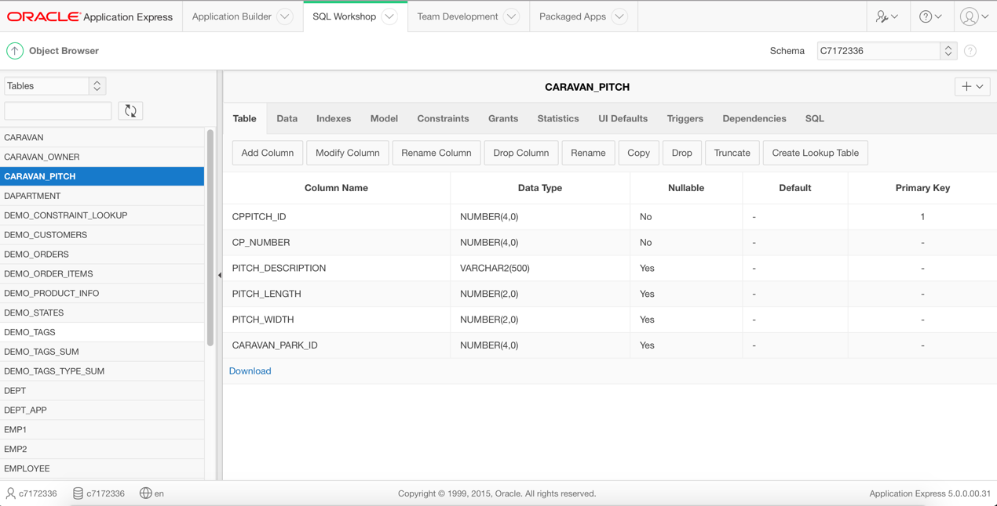

This table contains only 1 PK( cppitch_id), because I don’t have table Caravan_Park . Originally this table contains 1 PK(cppitch_id) and 1 FK(caravan_park). Columns have been well planned and data types carefully considered… Sequence for the PK column: “pitch_app_seq1” starts with 9

**Data:**

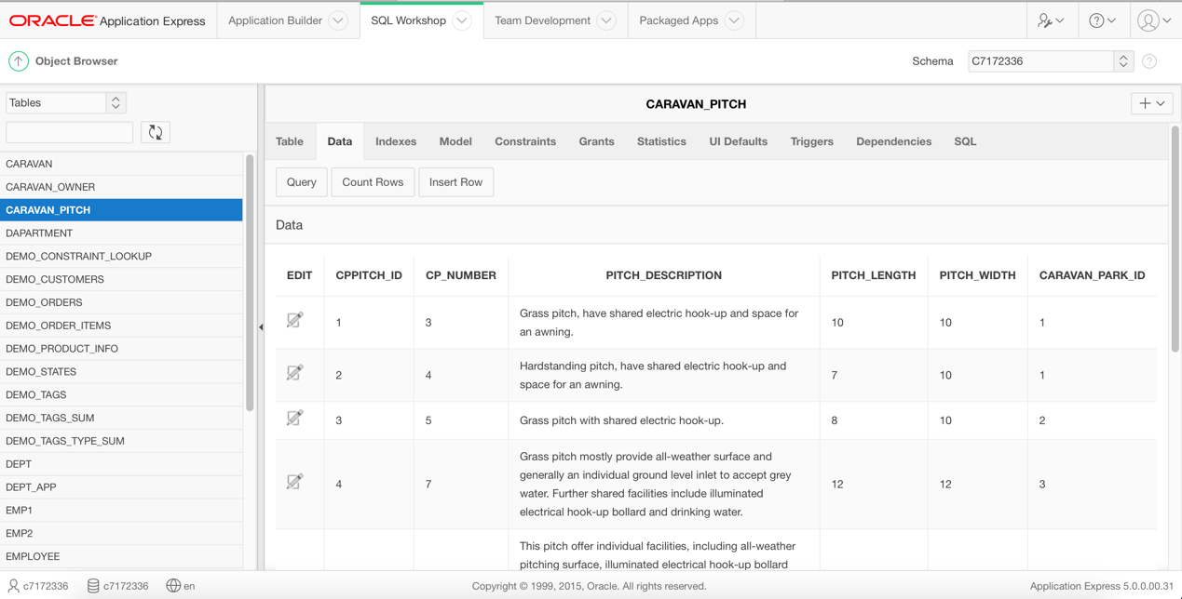

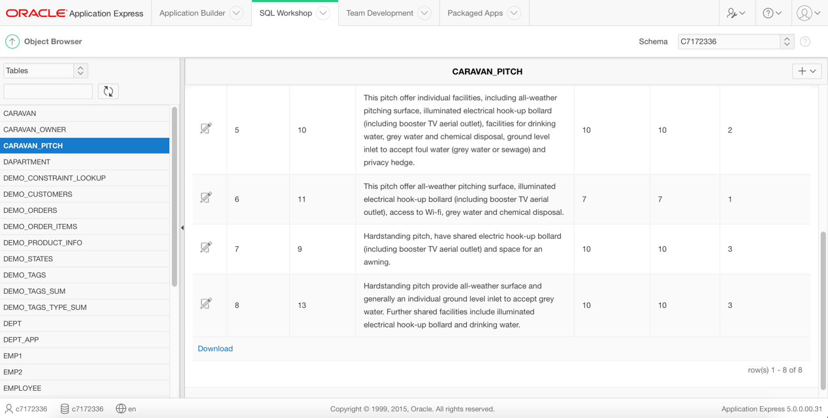

Table contains 3 caravan parks with unique pitches.

**Constraints:**

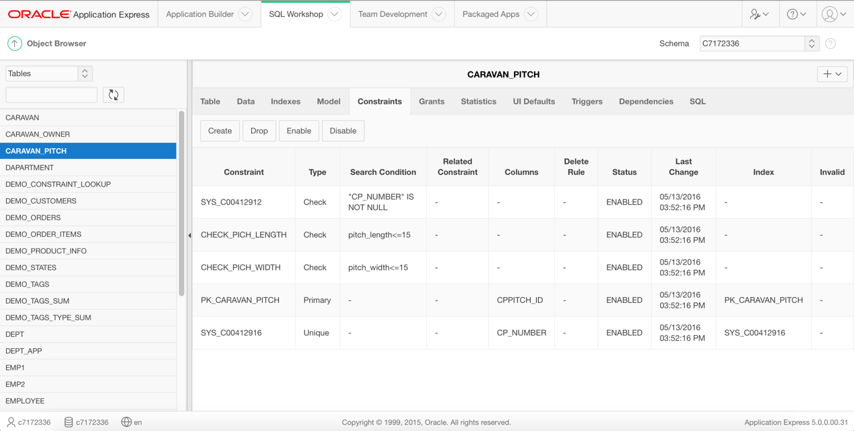

Primary KEY constraint for cppitch_id – every table must have a Primary Key.

NOT NULL + UNIQUE constraint for cp_number – unique pitch number.

CHECK constraint for length and width – In my Parks max legth,width 15 (m). I checked real pitches and usually the are <15 m.

**I created a view that contains all tables.**

# Table 2: Caravan

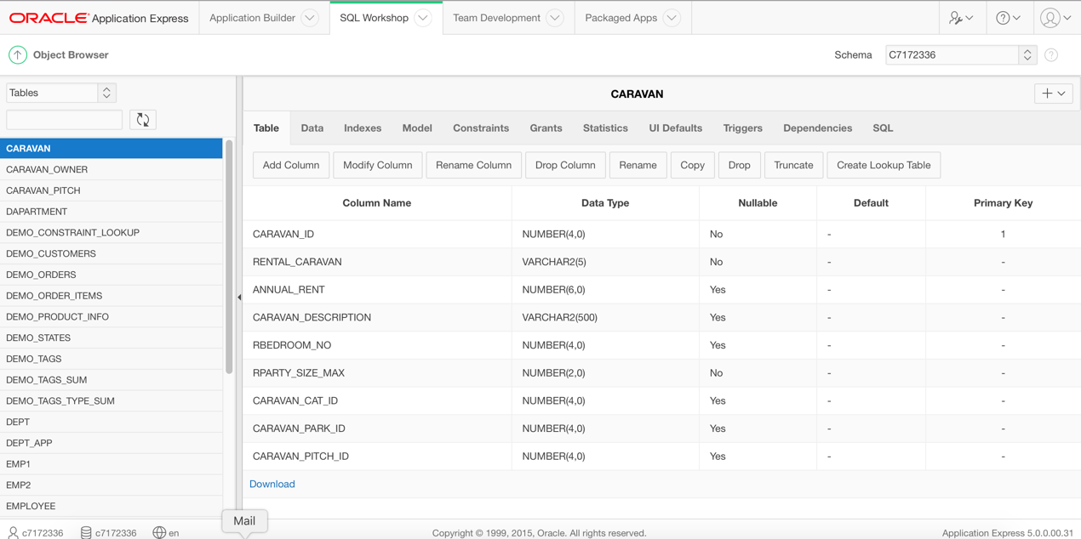

This table contains one PK(caravan_id) and one FK(caravan_pitch), because I don’t have table Caravan_Park . Originally this table contains 2 FK(caravan_park,caravan_pitch). One-to-one relationship between Caravan_Pitch and Caravan with optionality on Caravan table . For one Caravan only one Pitch. Columns have been well planned and data types carefully considered…   
Sequence for the PK column: “caravan_app_seq1” start with 9;starts with 9

# Data :

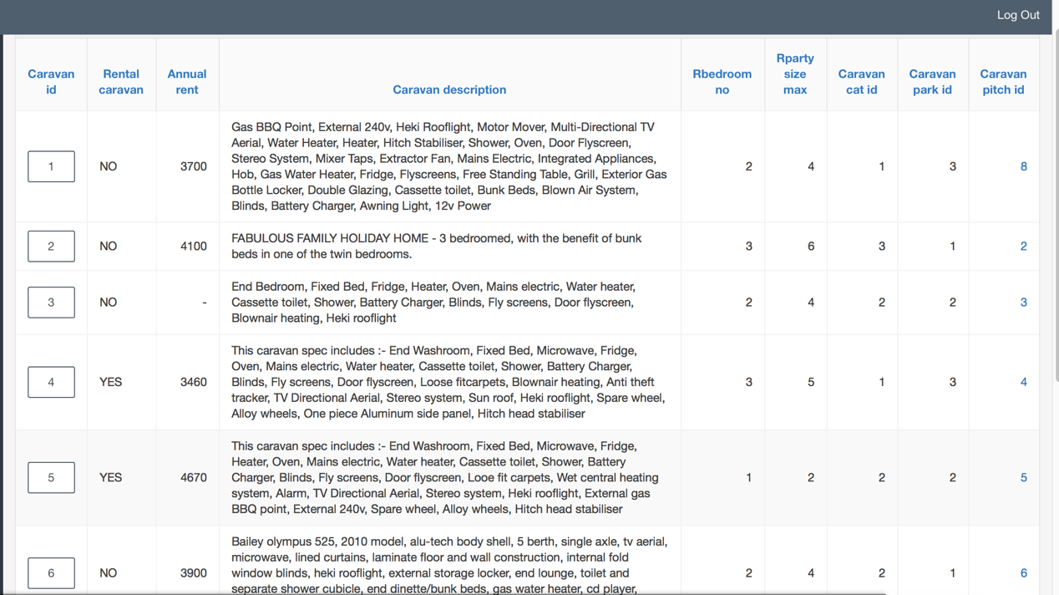

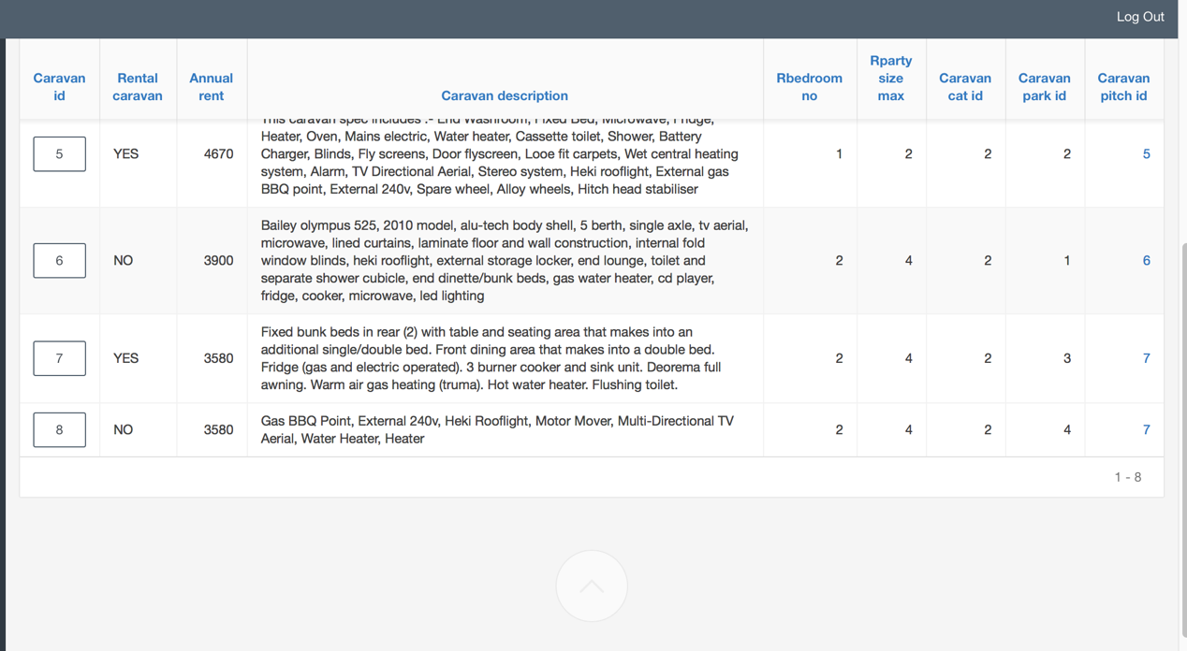

I have made ScreenShots in my Application, because in Object Browser in 1 ScreenShot- 1 Caravan, due to description and small resolution screen.

Caravan can have max 3 beds and 6 berths.

# Constraints:

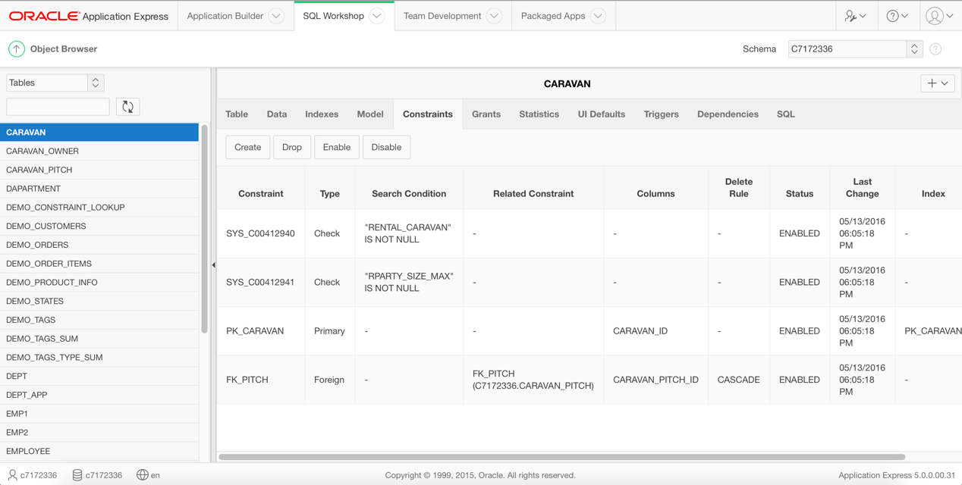

Primary KEY constraint for caravan_id – every table must have a Primary Key.

NOT NULL constraint for rental_caravan – YES(Happy Holiday’s) or NO(private).

NOT NULL constraint for RParty_size_max – every caravan must contain info at least about berths NO.

Foreign KEY constraint for caravan_pitch – reference to Caravan_Pitch table.

**I created a view that contains all tables.**

# Table 3: Owner

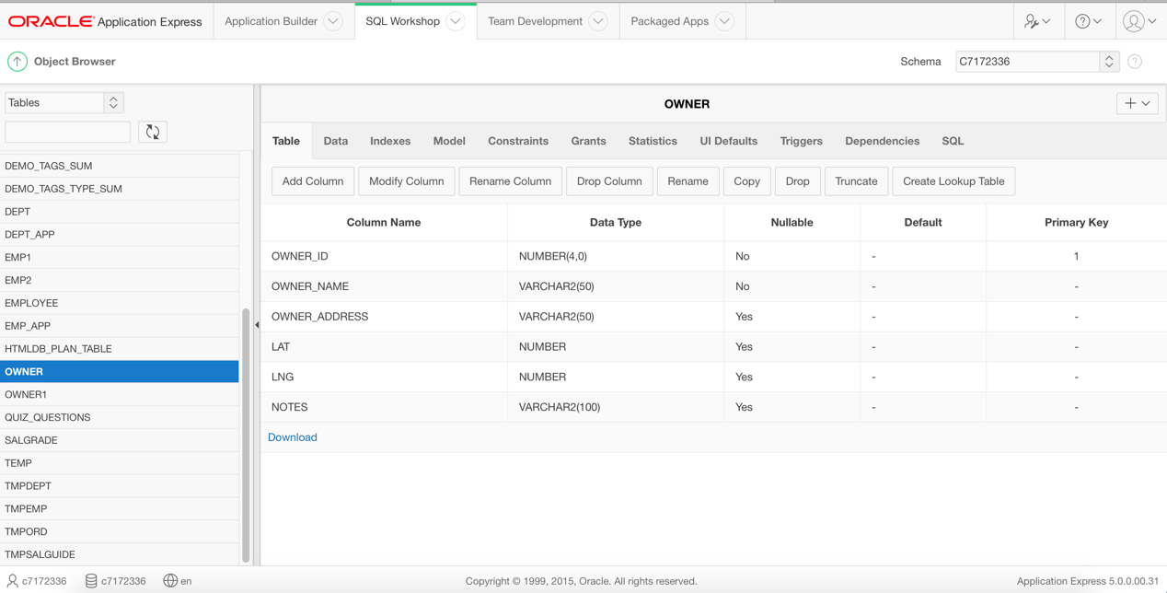

This table contains one PK(owner_id). Columns have been well planned and data types carefully considered… I added lat(latitude) and lng(longitude) columns for address, because I need them for my google map plug-in Sequence for the PK column: “owner_app_seq1” start with 6;

# Data :

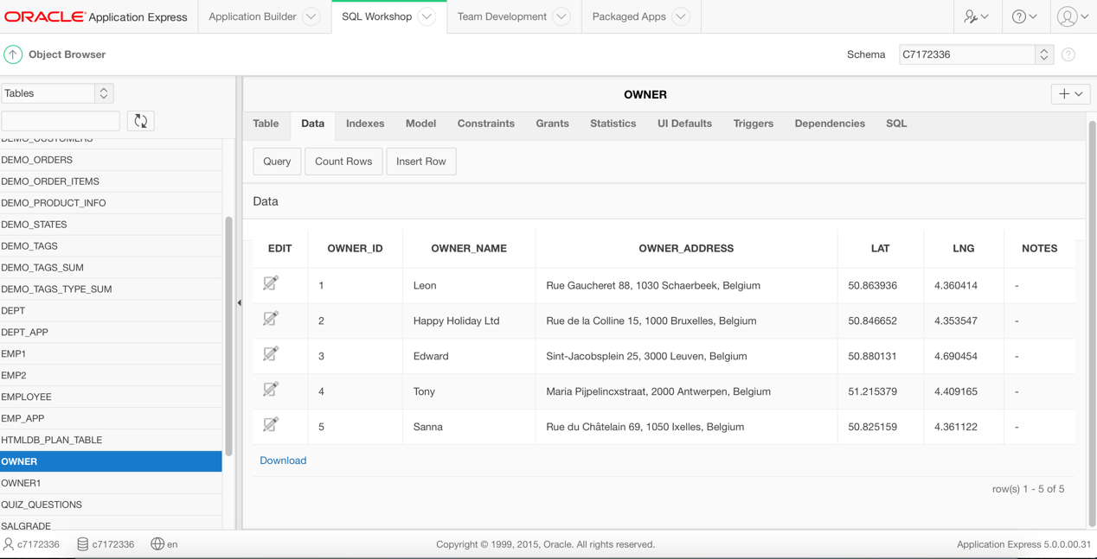

Five owners for basic manipulations.

# Constraints:

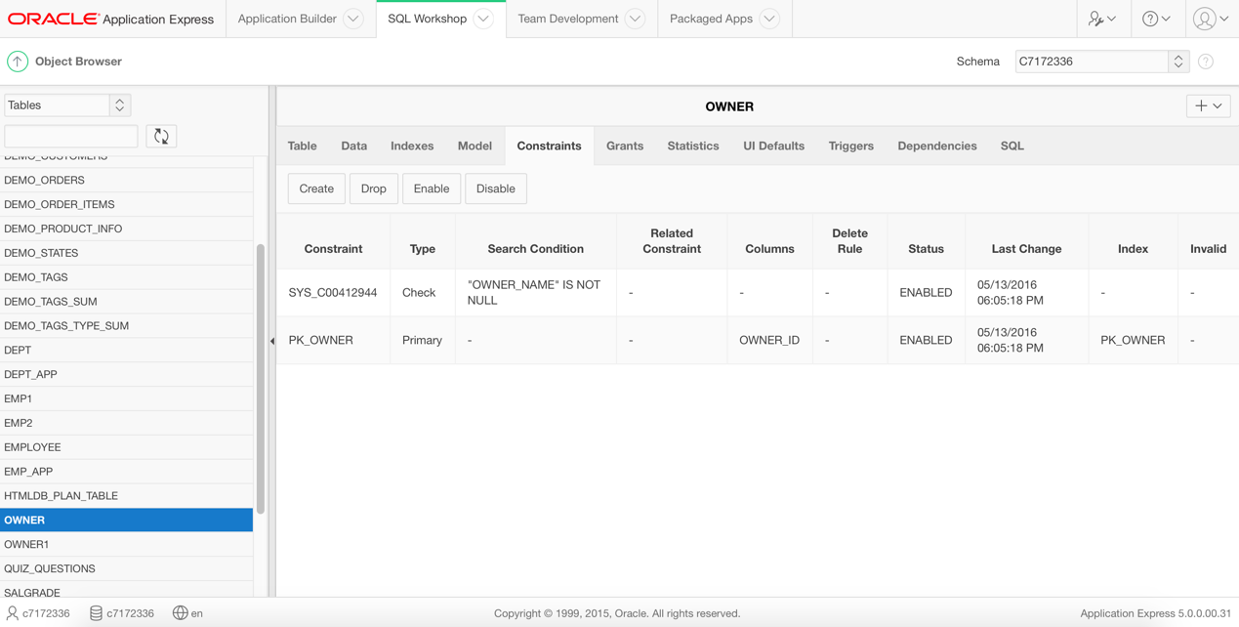

Primary KEY constraint for owner_id – every table must have a Primary Key.

NOT NULL constraint for owner_name – owner must have a name.

**I created a view that contains all tables.**

# Table 4: Caravan_Owner

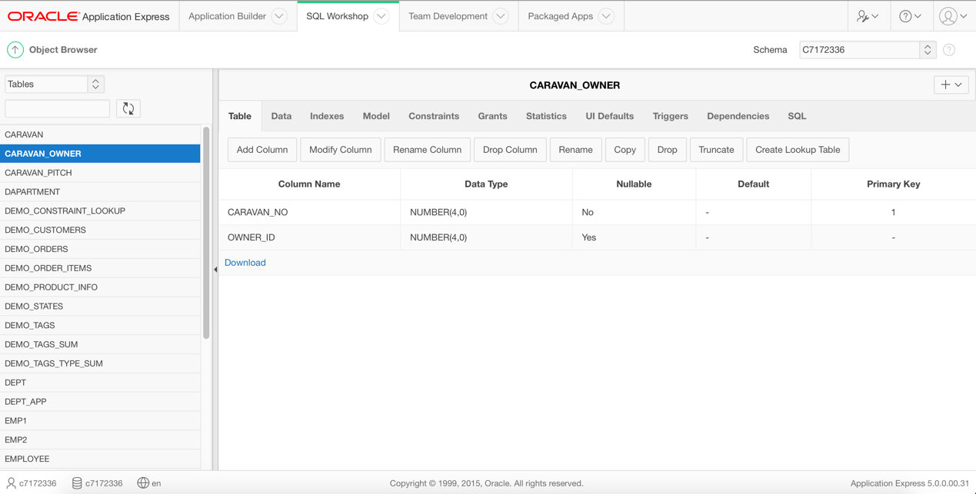

This table contains one PK(caravan_id) and two FK(caravan_id,owner_id). This is a new derived table, because relationship between Caravan and Owner is one-to-many with optionality on Owner table. Columns have been well planned and data types carefully considered…   
Sequence for the PK column: “caravan_owner_app_seq1” start with 9;

# Data :

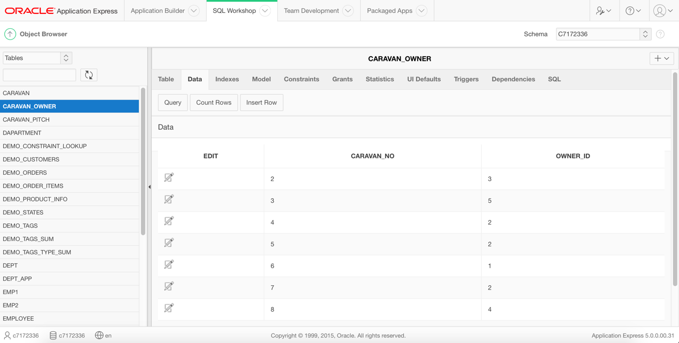

For each caravan 1 owner.

# Constraints:

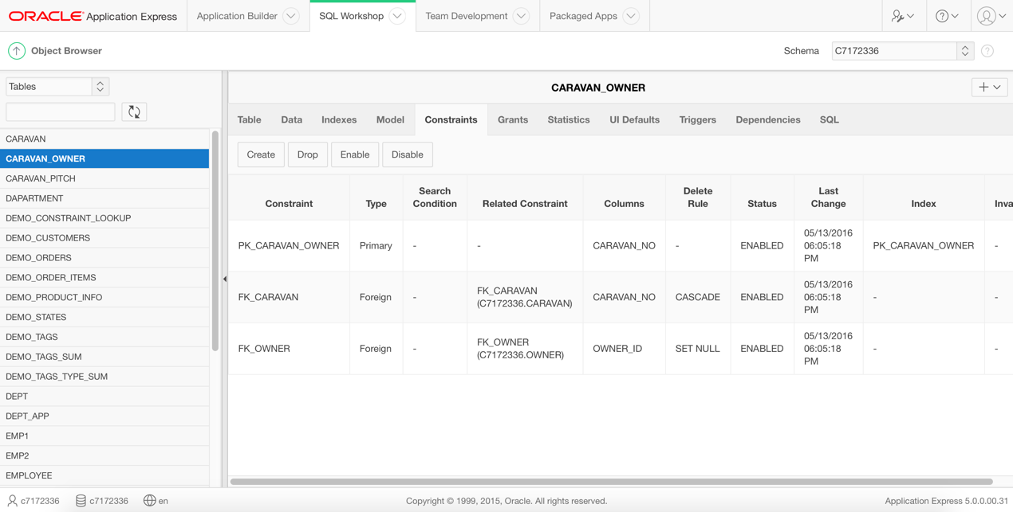

Primary KEY constraint for caravan_no – every table must have a Primary Key.

Foreign KEY constraint for caravan_no – reference to Caravan table.

Foreign KEY constraint for owner_id – reference to Owner table.

**I created a view that contains all tables**

# VIEW and test of the view

**CREATE OR REPLACE VIEW car_desc**

**AS**

**SELECT cppitch_id,cp_number,caravan_no,rental_caravan,rbedroom_no,rparty_size_max,owner_name**

**FROM caravan_pitch,caravan,owner,caravan_owner**

**WHERE caravan_pitch.cppitch_id=caravan.caravan_pitch_id**

**AND caravan.caravan_id=caravan_owner.caravan_no**

**AND owner.owner_id=caravan_owner.owner_id;**

**--Test View**

**SELECT \***

**FROM car_des**

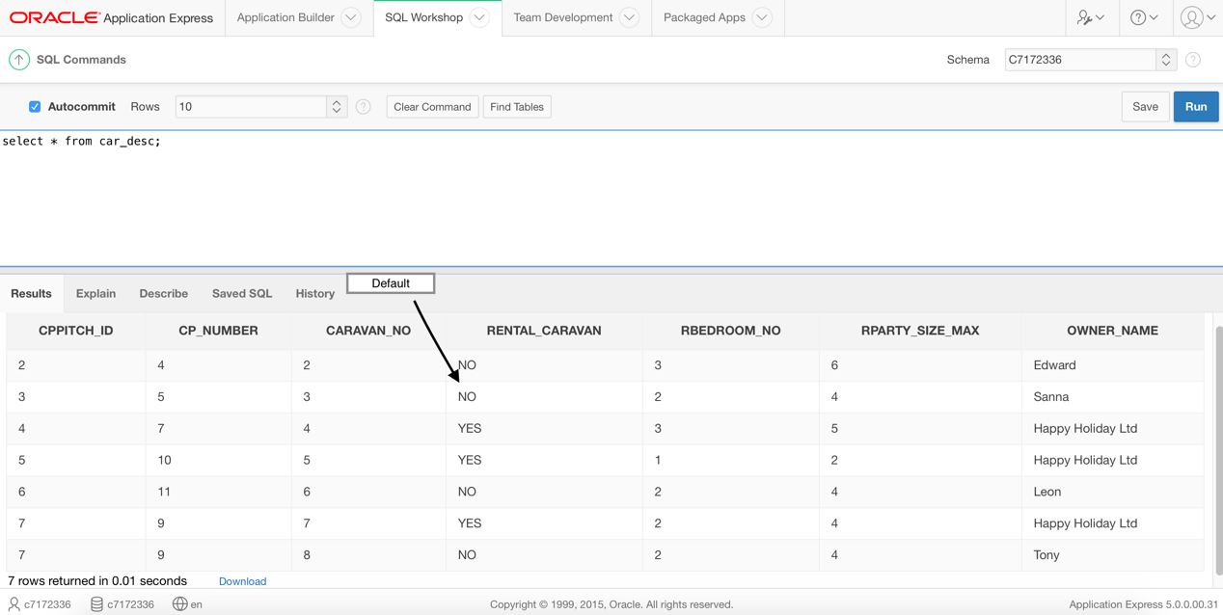

**UPDATE car_desc   
SET rental_caravan='yes'   
WHERE caravan_no=3;**

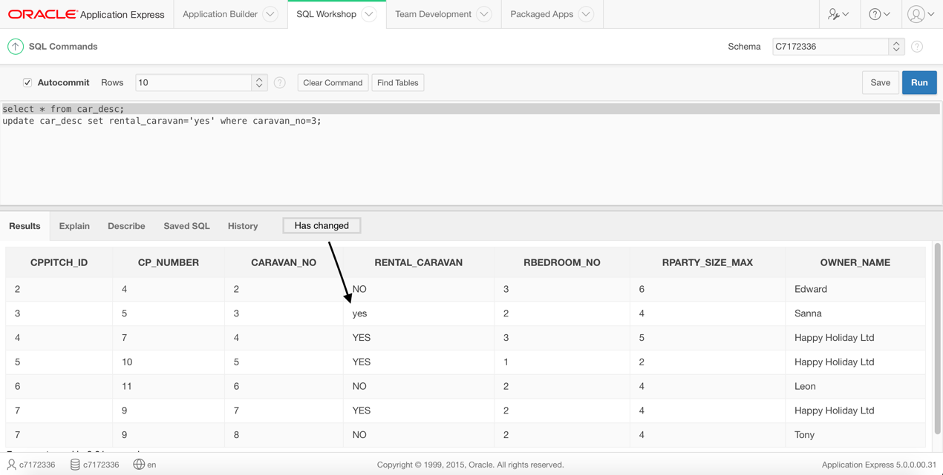

**SQL Code:**

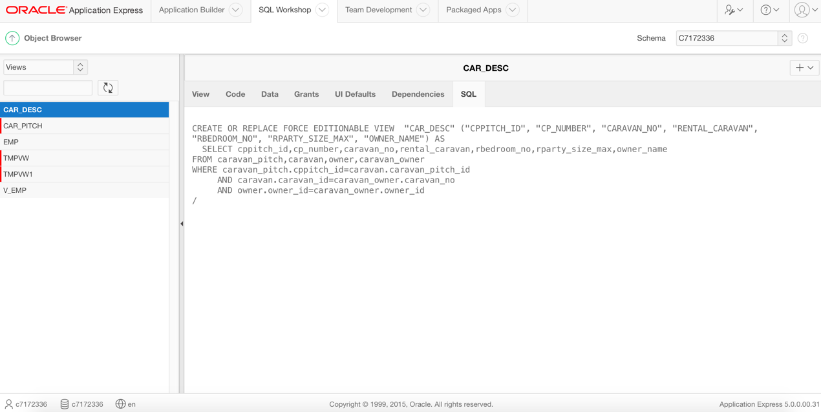

# Step 2: Implemented 3 suitable reports based on SQL queries.

**Report 1: MultiCaravan Owners (Find owners, who have more than 1 caravans and show monthly rent.)**

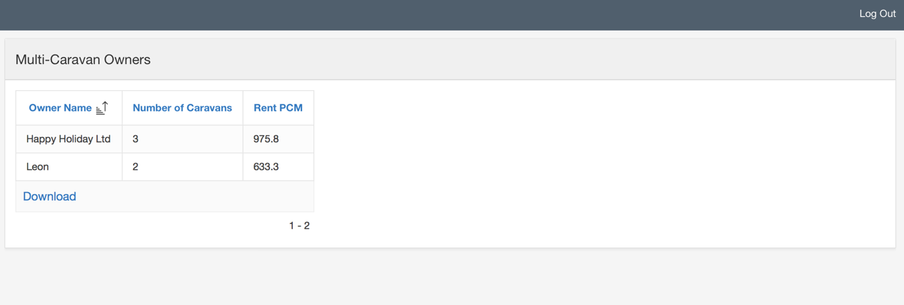

**SQL code:**

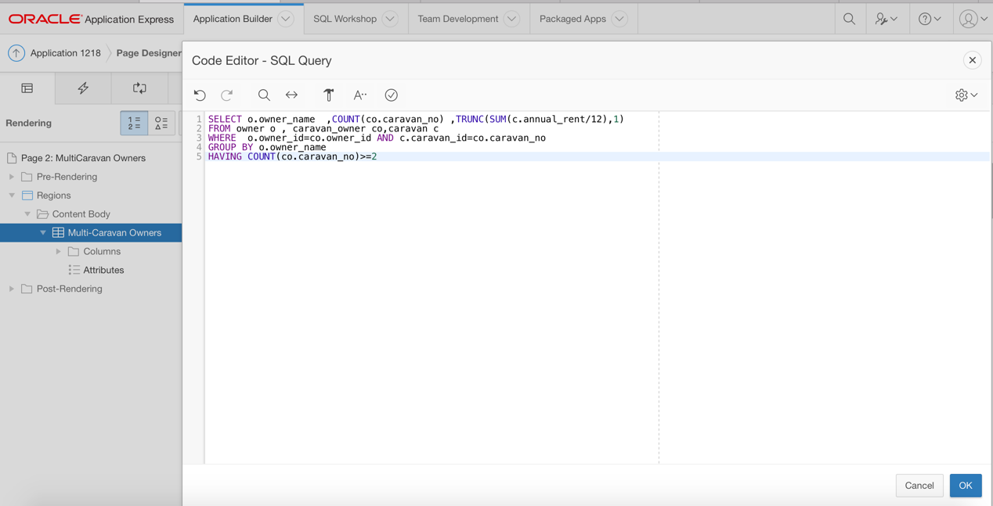

**Report 2: Owners of Caravans at Diff. Parks (Find owners, who have their caravans at more than one site.)**

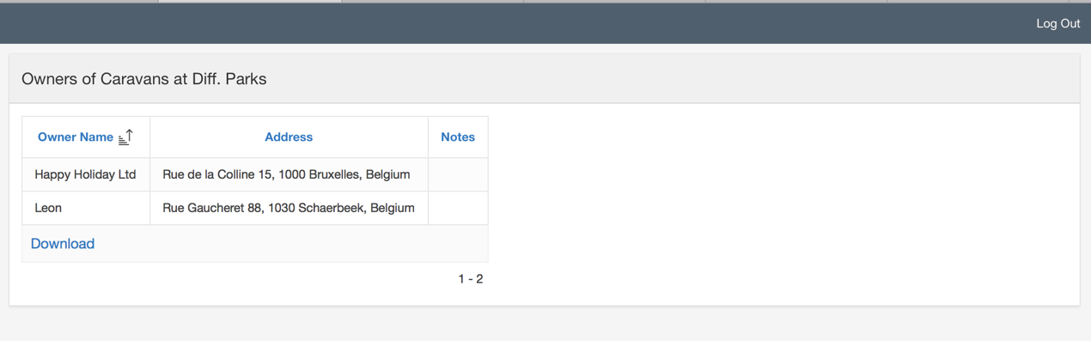

**SQL code:**

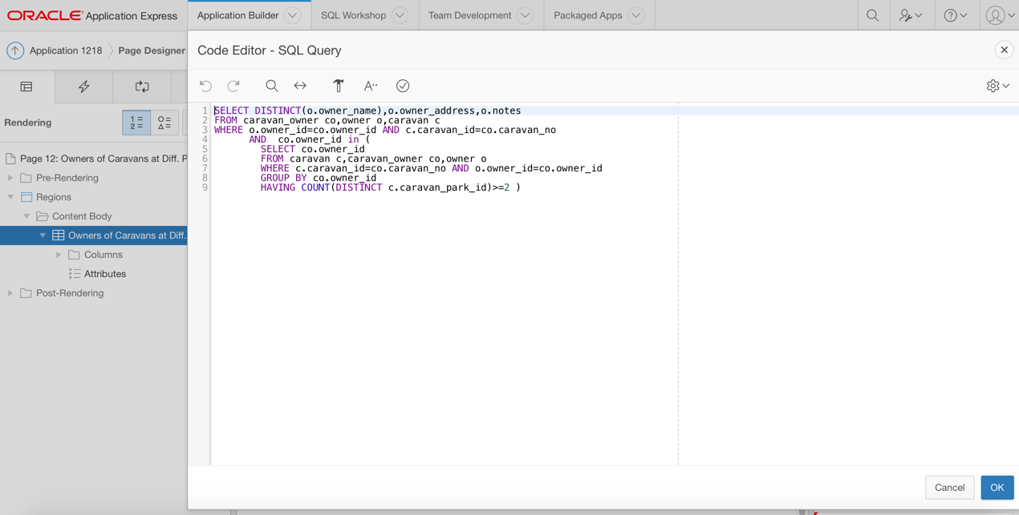

**Report 3: Max Berth's Caravan by Park (For every caravan park find caravan with max sleeps beds)**

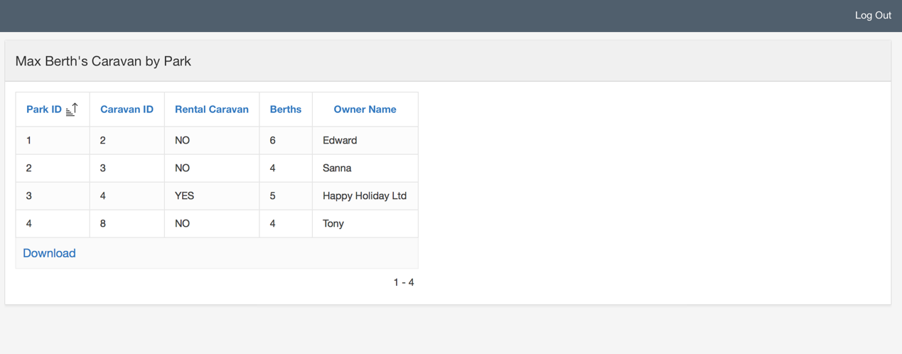

**SQL code:**

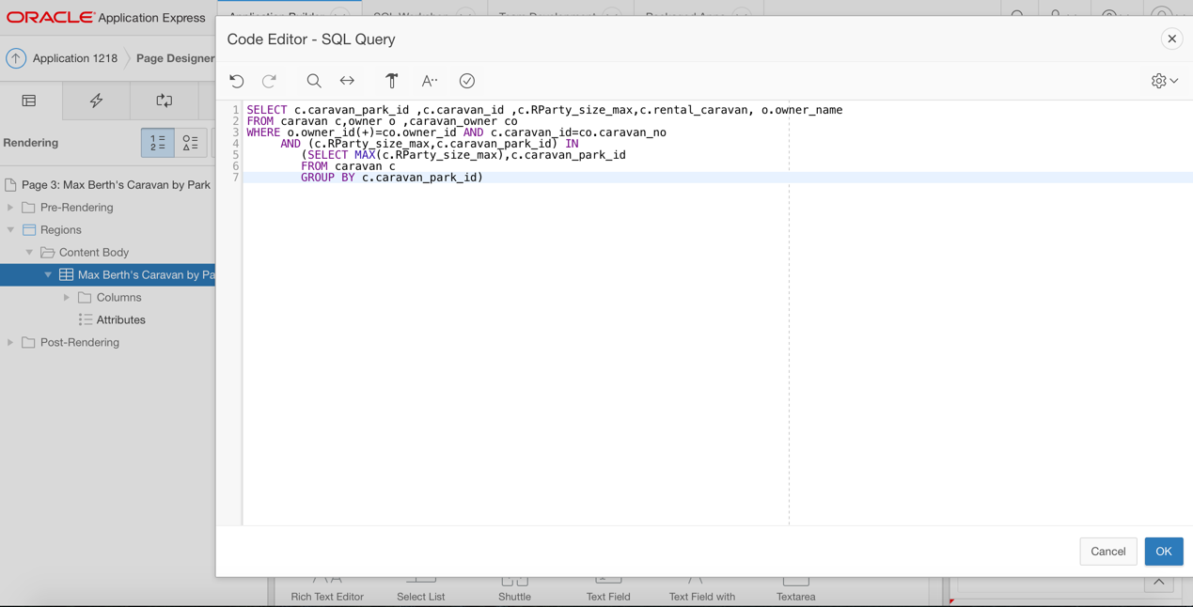

# Steo 3: Implemented two triggers as procedural constraints for use within the Apex application.

**Trigger 1 Code: Check caravan for corrects berths number:**

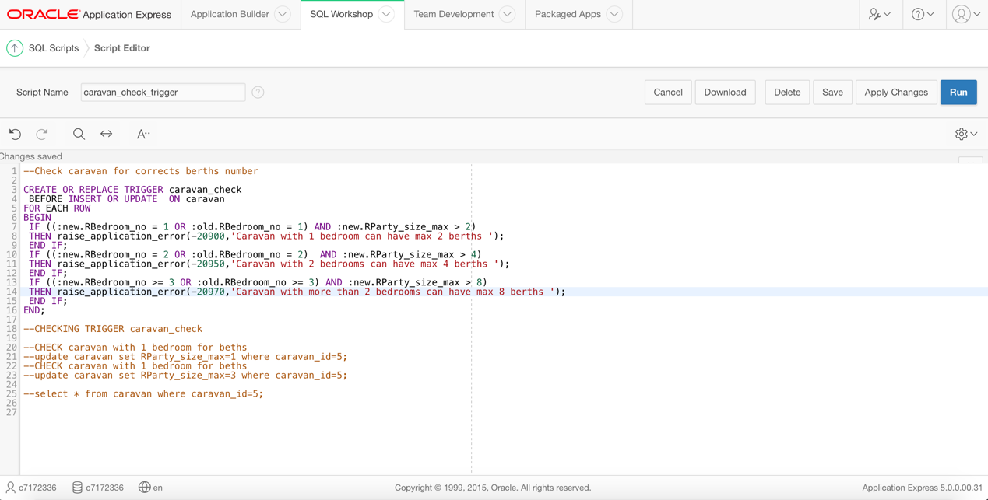

**Trigger 1 Test:**

**First update :**

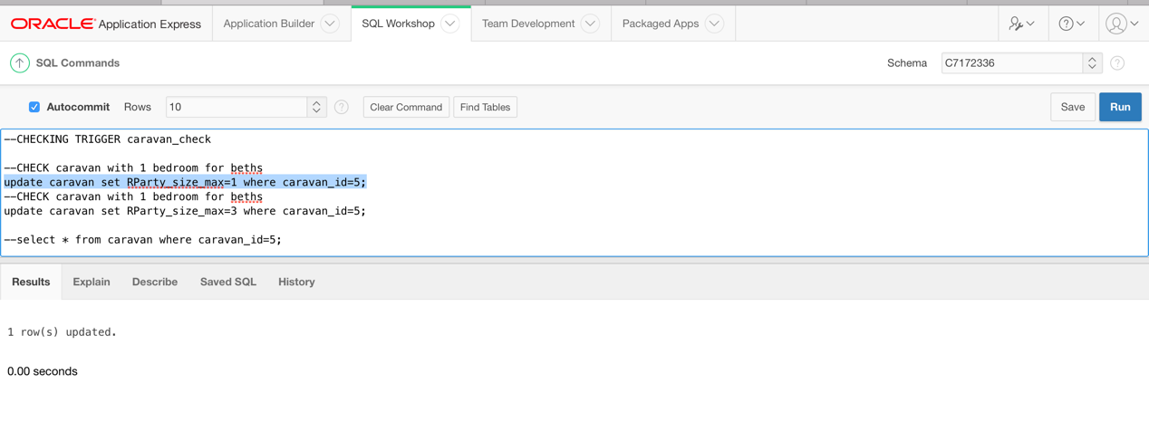

**Second Update:**

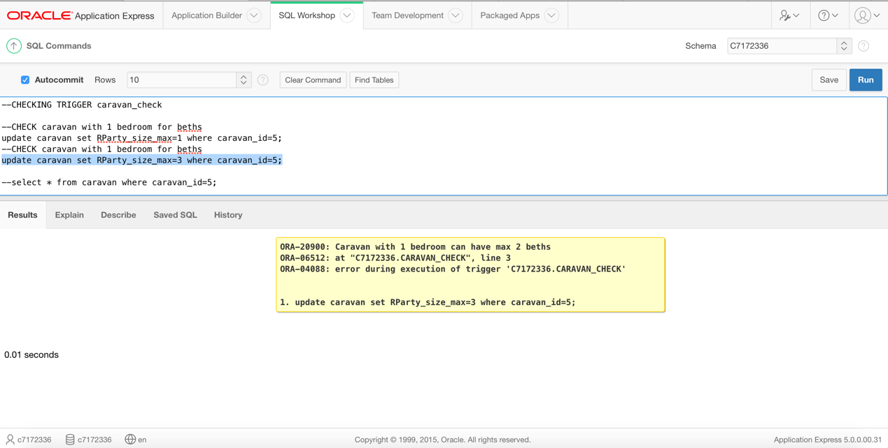

**Trigger 2: Prevent adding value of rental_caravan except "yes" or "no"**

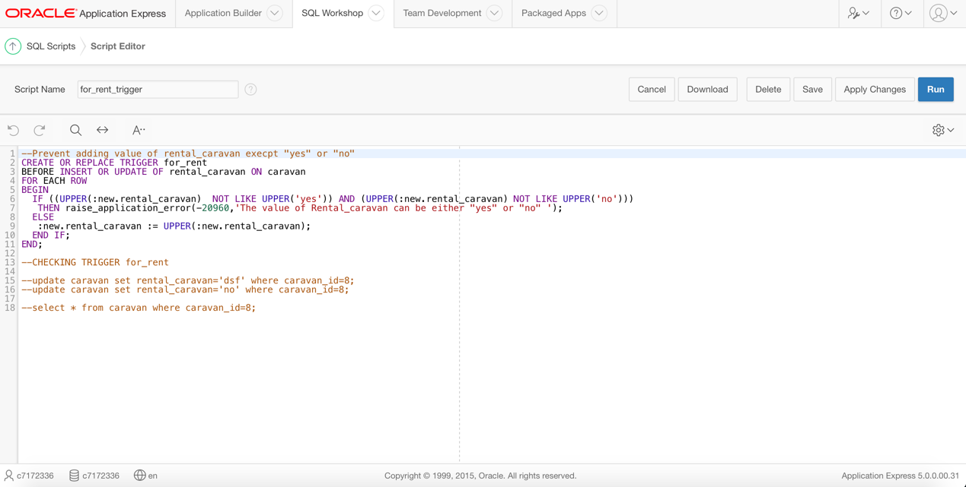

**First update :**

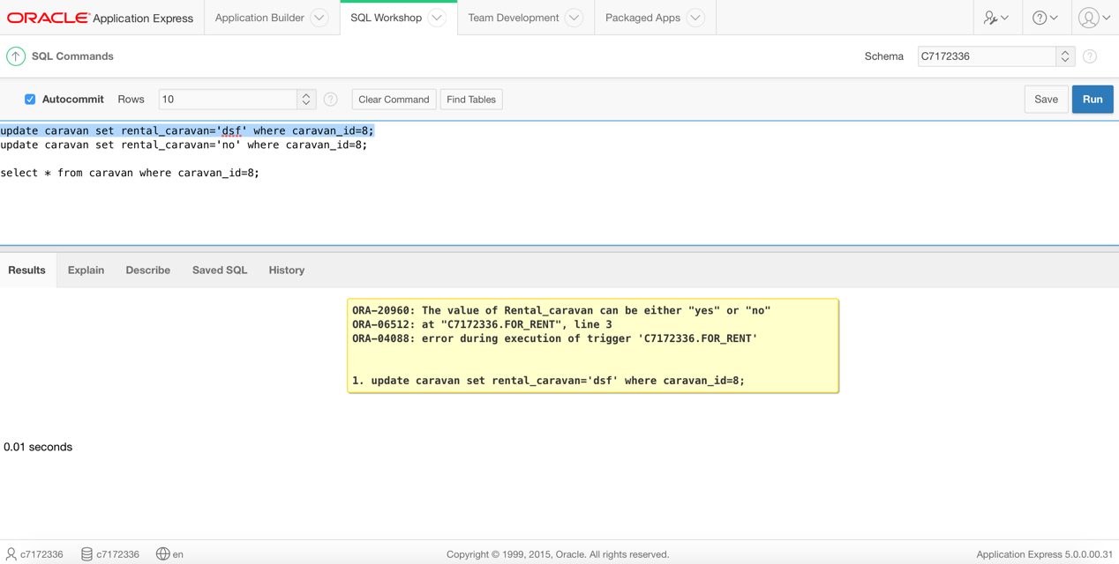

**Before second update:**

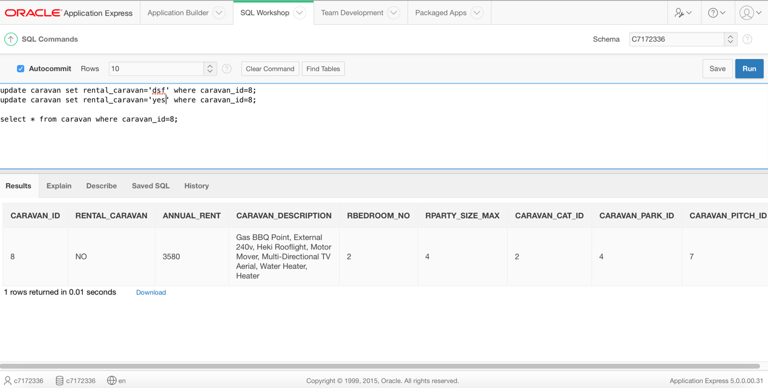

**Second Update:**

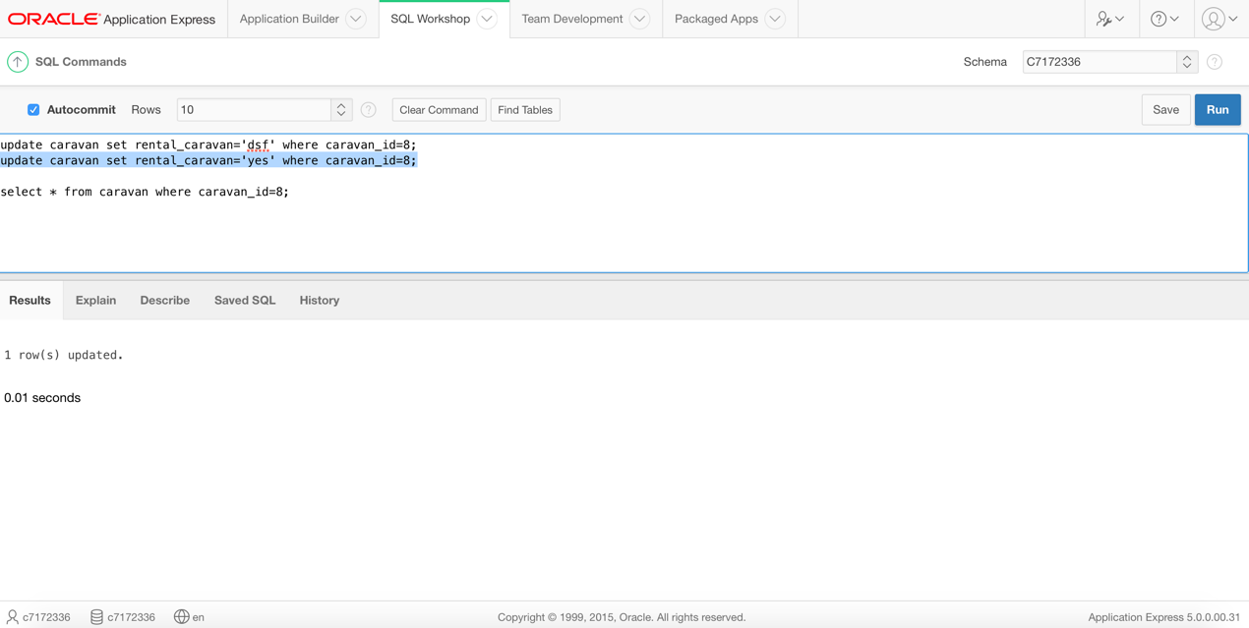

**After second update:**

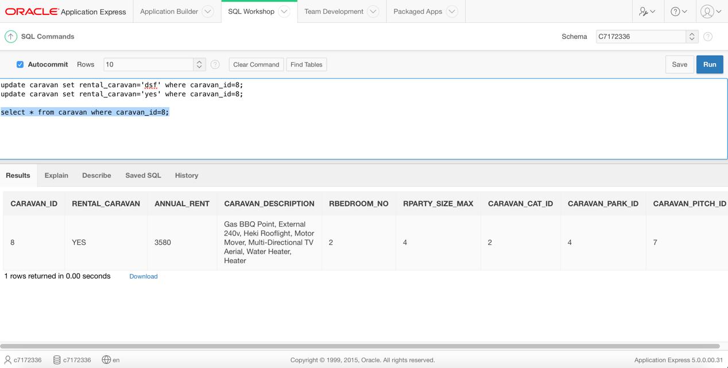

# Step 4: Application Builder

# Home Page:

Home Page with Static Content at Breadcrumb Bar and 2 Regions of Media Lists.

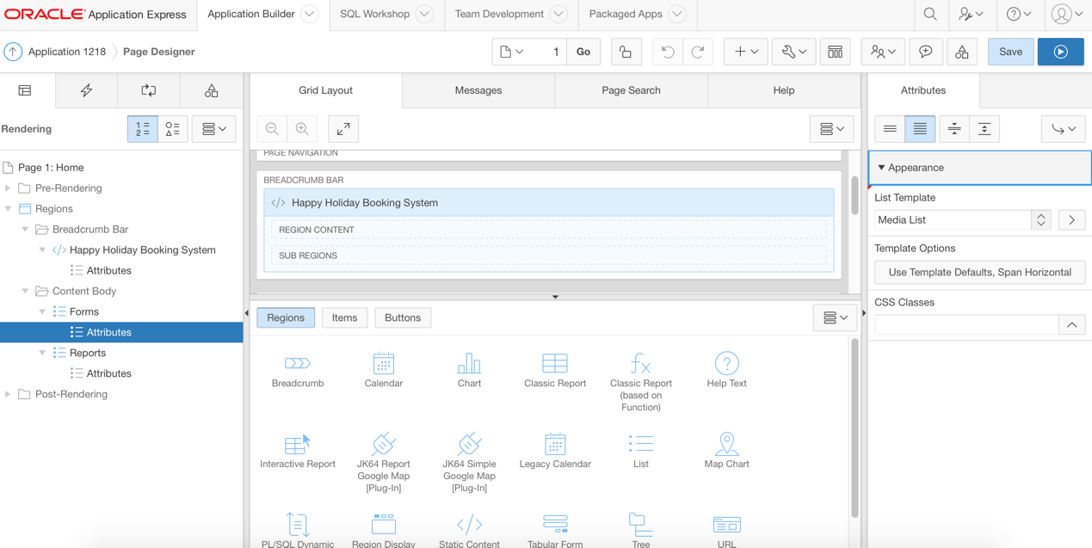

**Form List:**

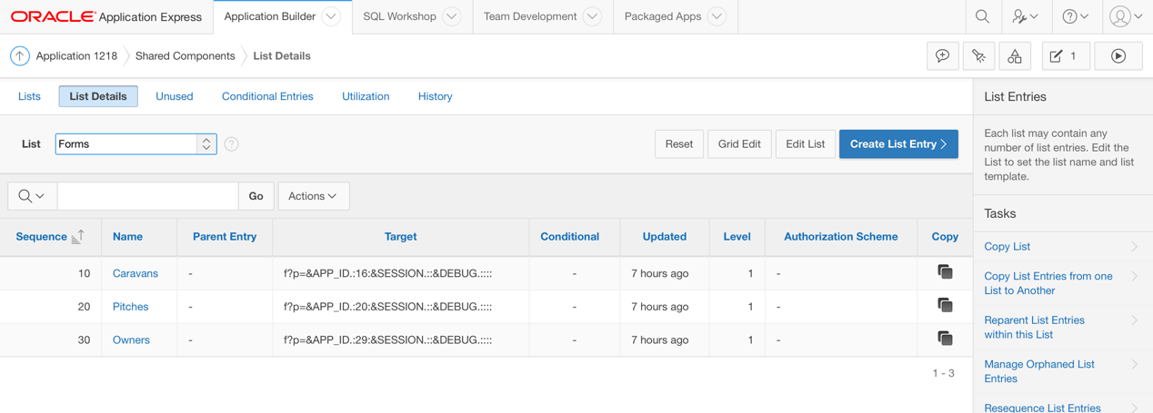

**Report List:**



# Form 1: Page Caravans

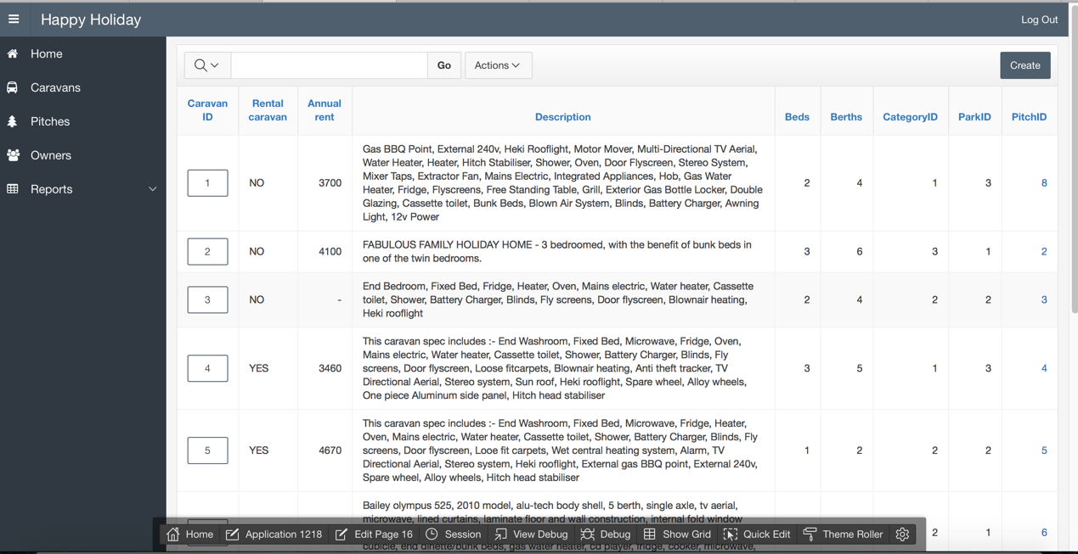

PitchID is a link to the specific Pitch.

**Link to the PitchID 8:**

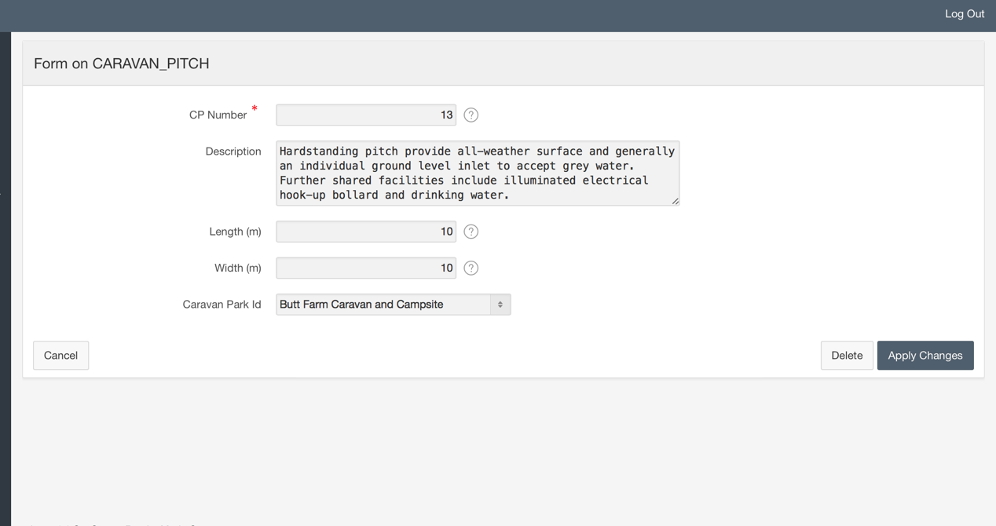

**CREATE Caravan:**

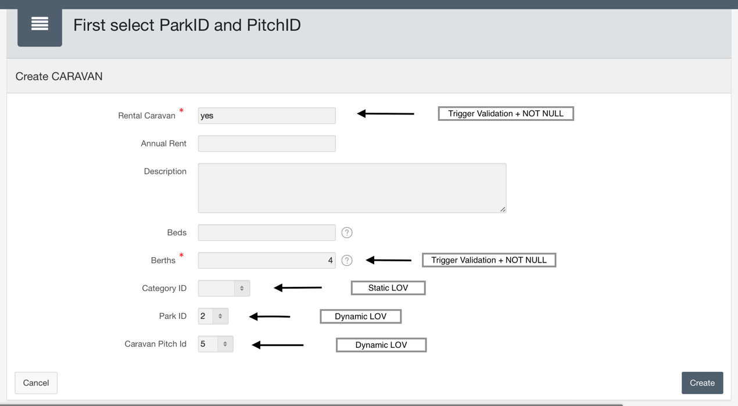

In Order to Create Caravan,first you have to select Park ID(dynamic LOV), because every time you choose ParkID, page reloads.

**See below why reloads:**

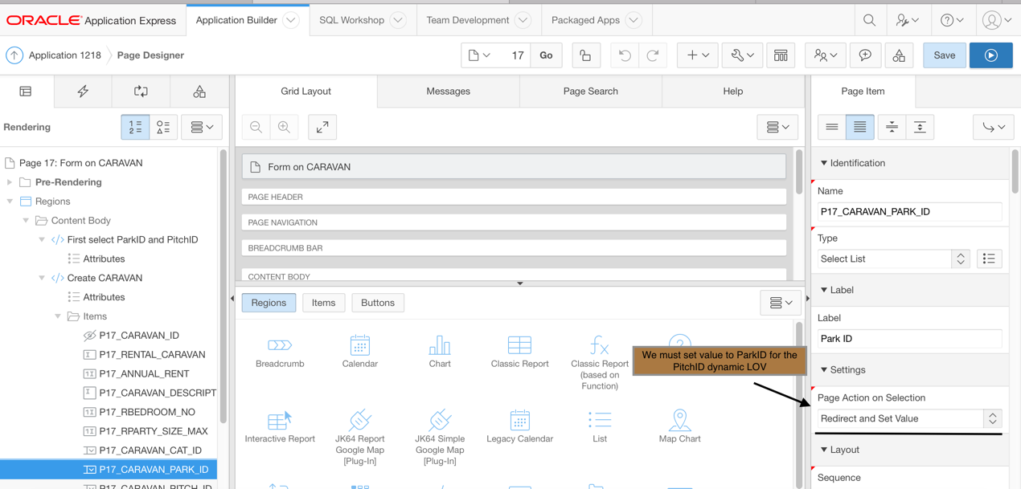

**ParkID SQL code:**

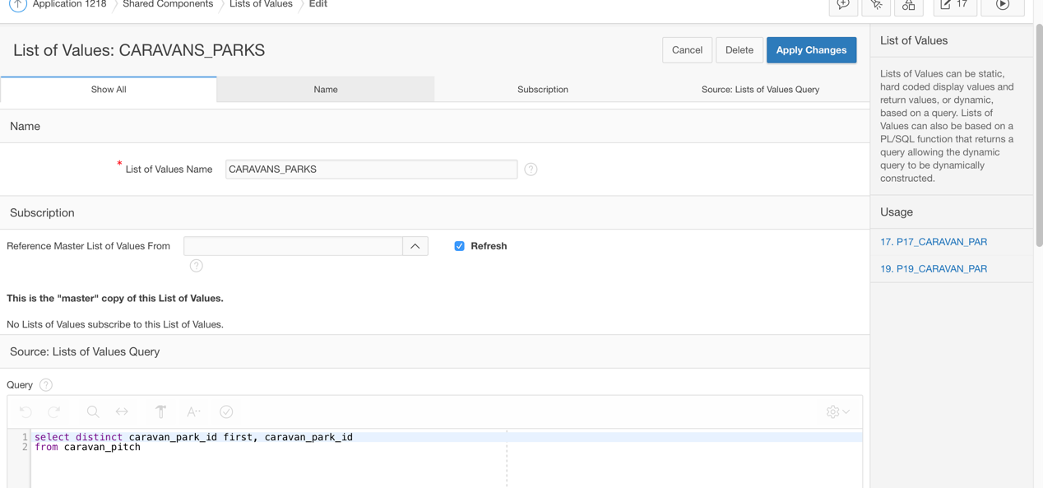

**PitchID SQL code:**

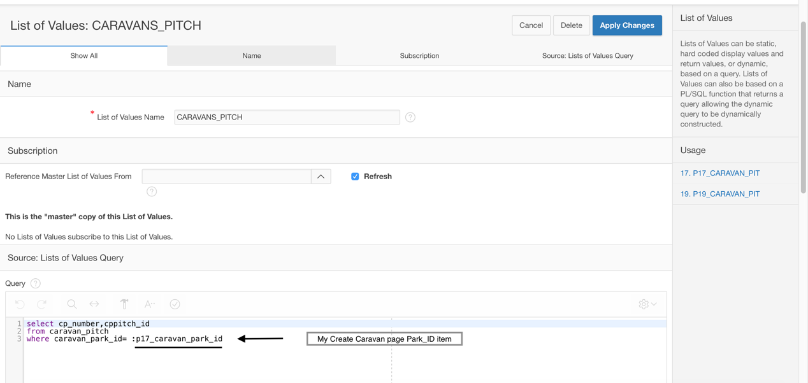

**Static LOV for Category Item:**

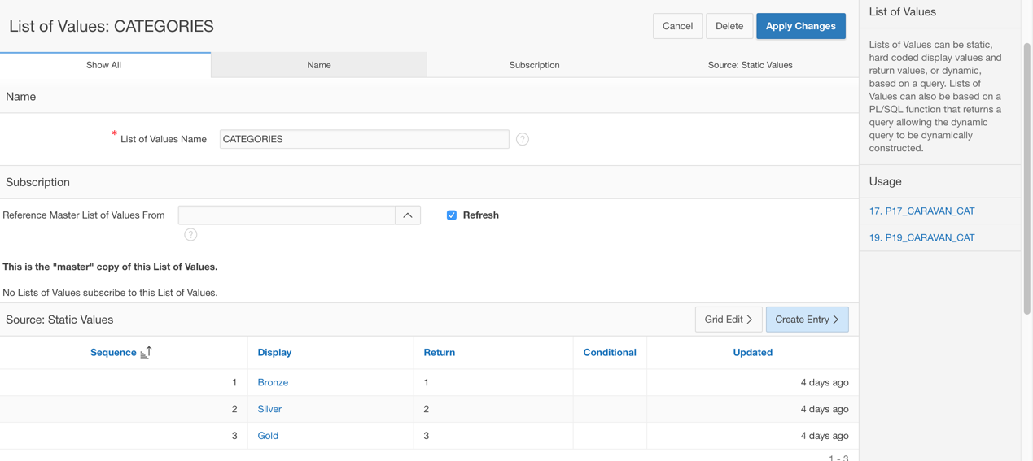

Rental Caravan (can either yes or no)

Beds(max 3) - Setted as a max value in Settings

Berths (max 6) - Setted as a max value in Settings + trigger validation for beds-berths No

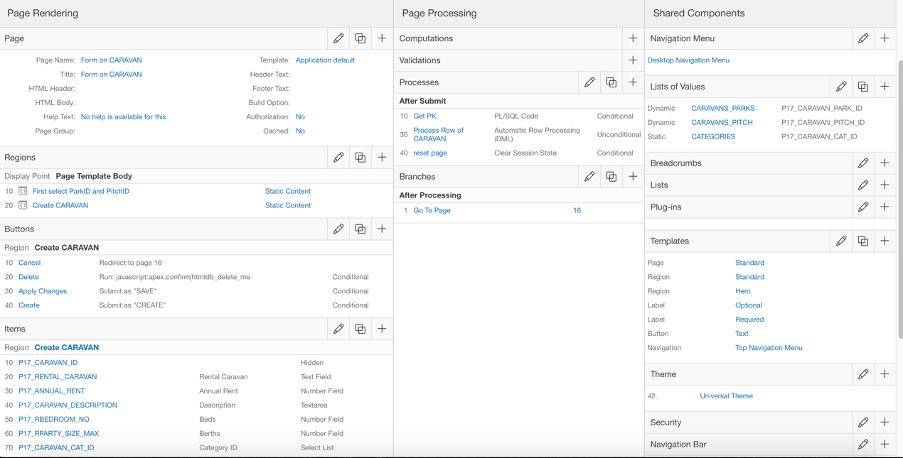

# INSERT Caravan: A new caravan record inserted:

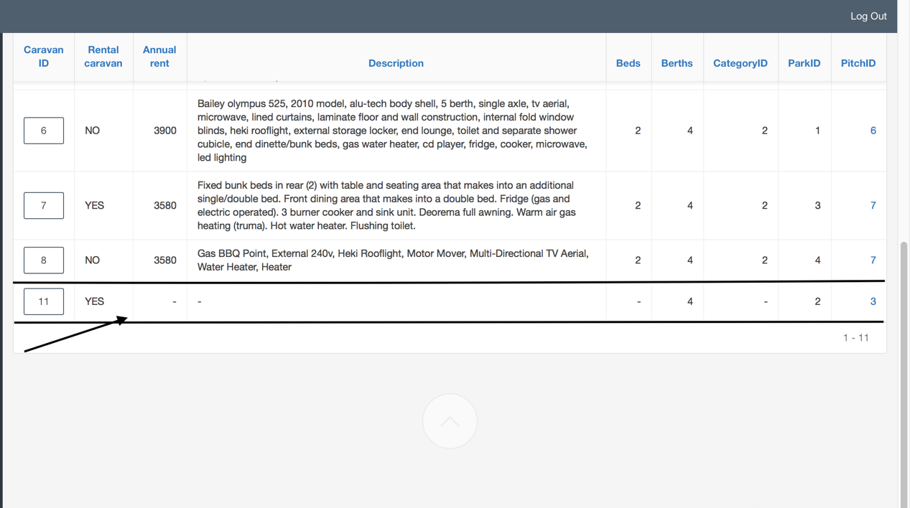

# UPDATE Caravan: a caravan No11 has been changed:

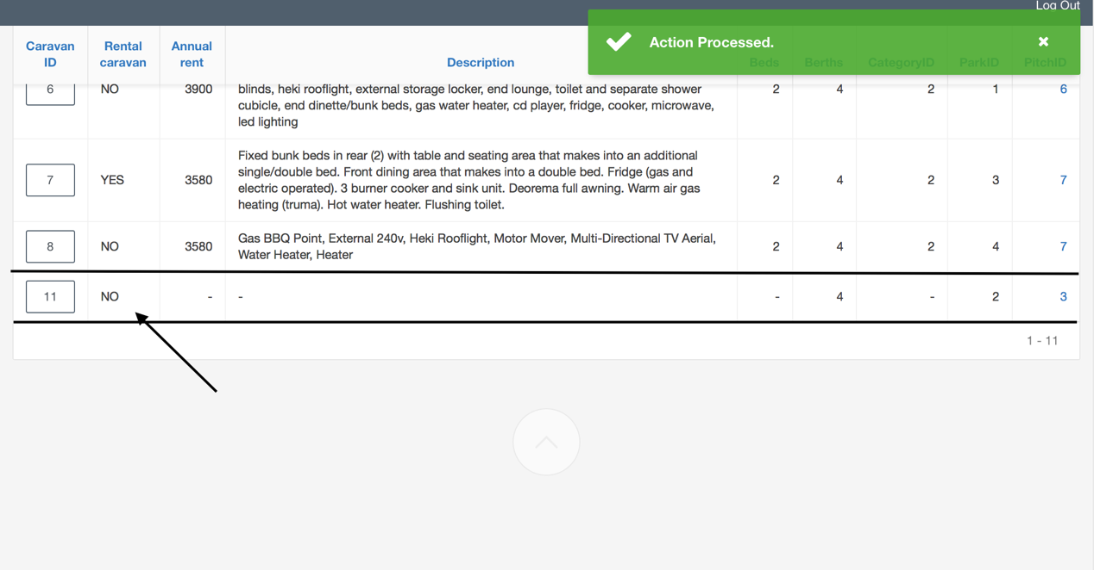

# DELETE caravan: a caravan No11 has been deleted:

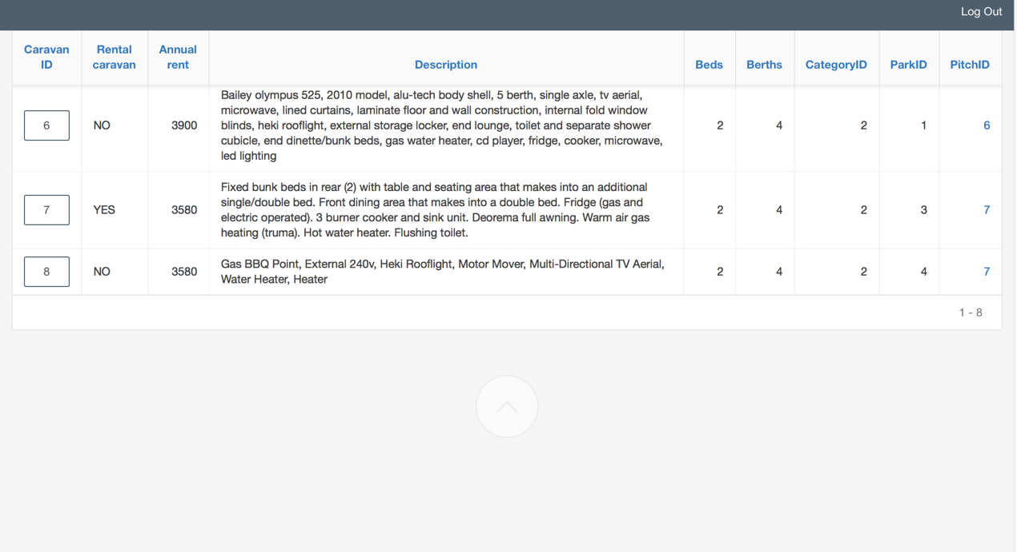

# Form 2: Page Pithes



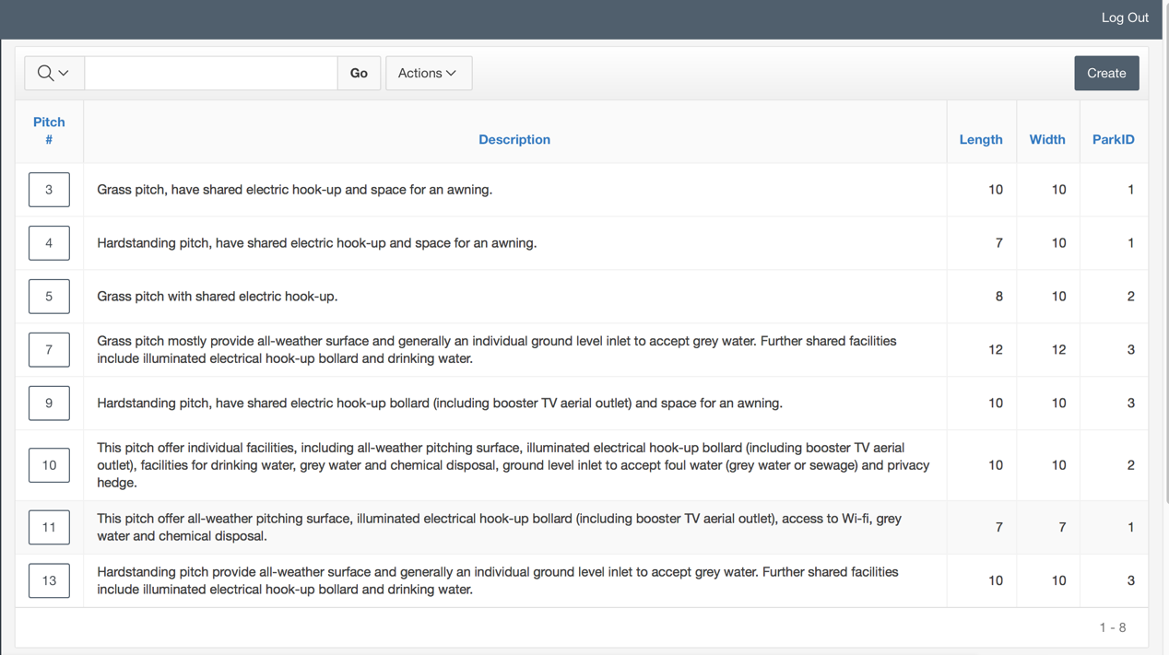

**CREATE Pitch:**

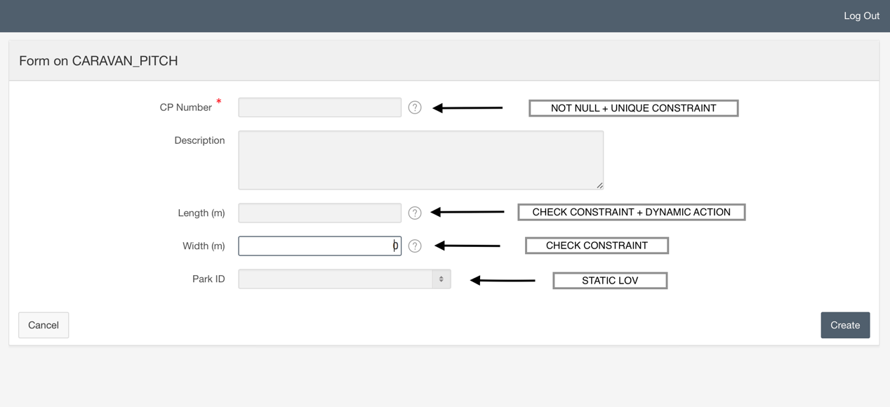

Length and Width can be max 15 (m).

**Dynamic Action:**

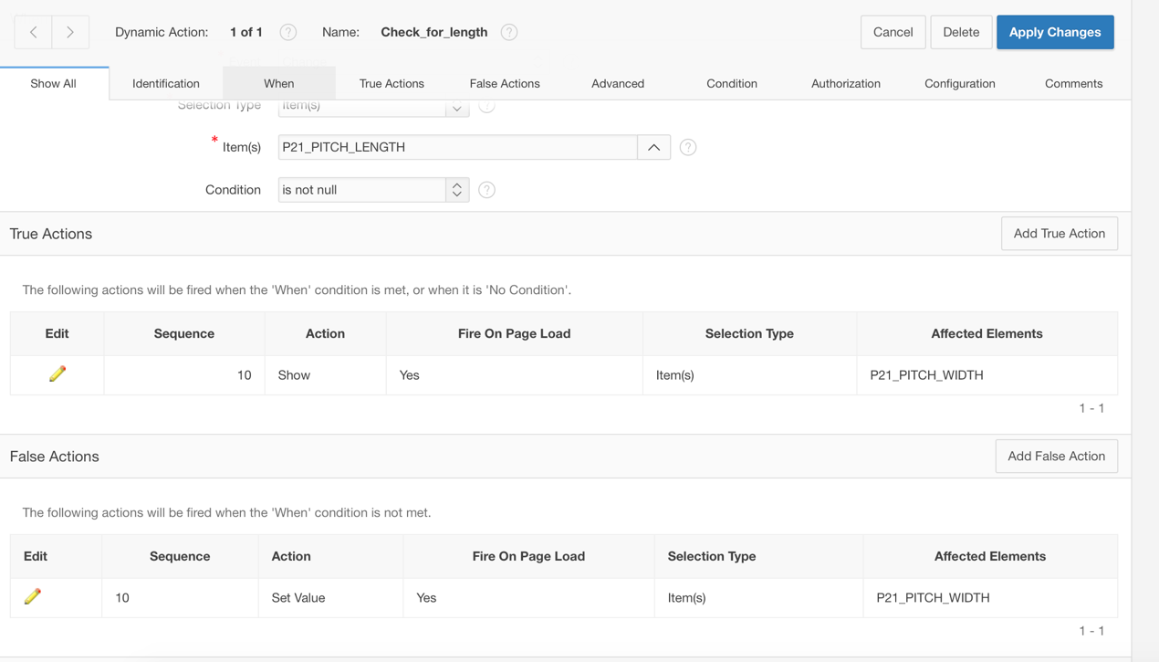

If Length is null -> Width 0 .

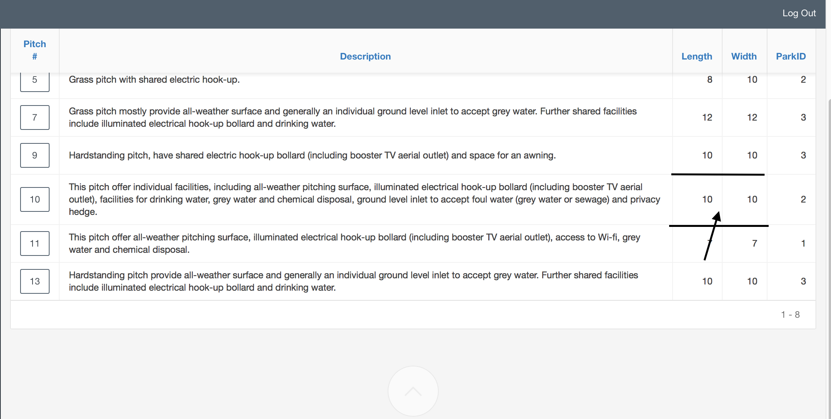

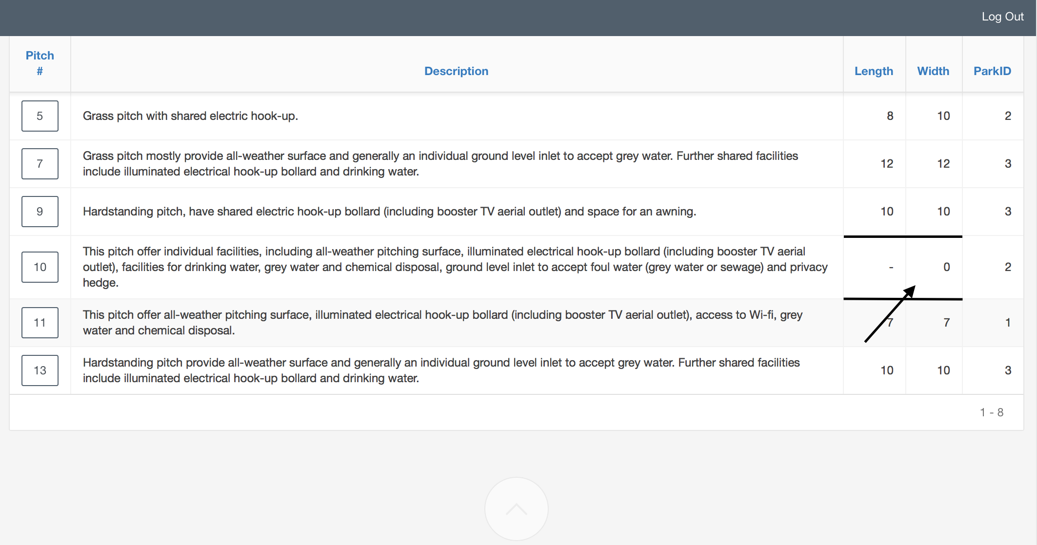

**ParkID Static LOV:**

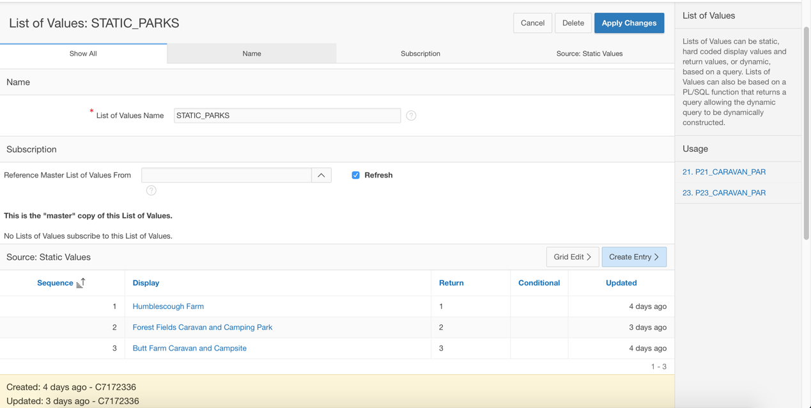

As my Booking System has only 3 Parks, I decided create Static LOV for user to select name, instead of number. Originally instead of Static LOV has to be Dynamic LOV based on Park table.

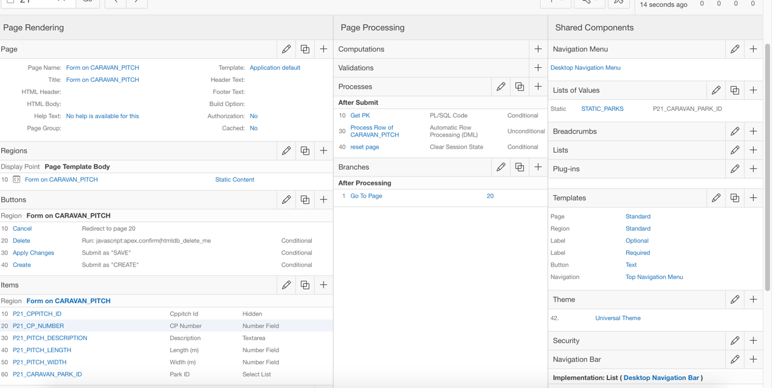

# INSERT Pitch: A new pitch record inserted:

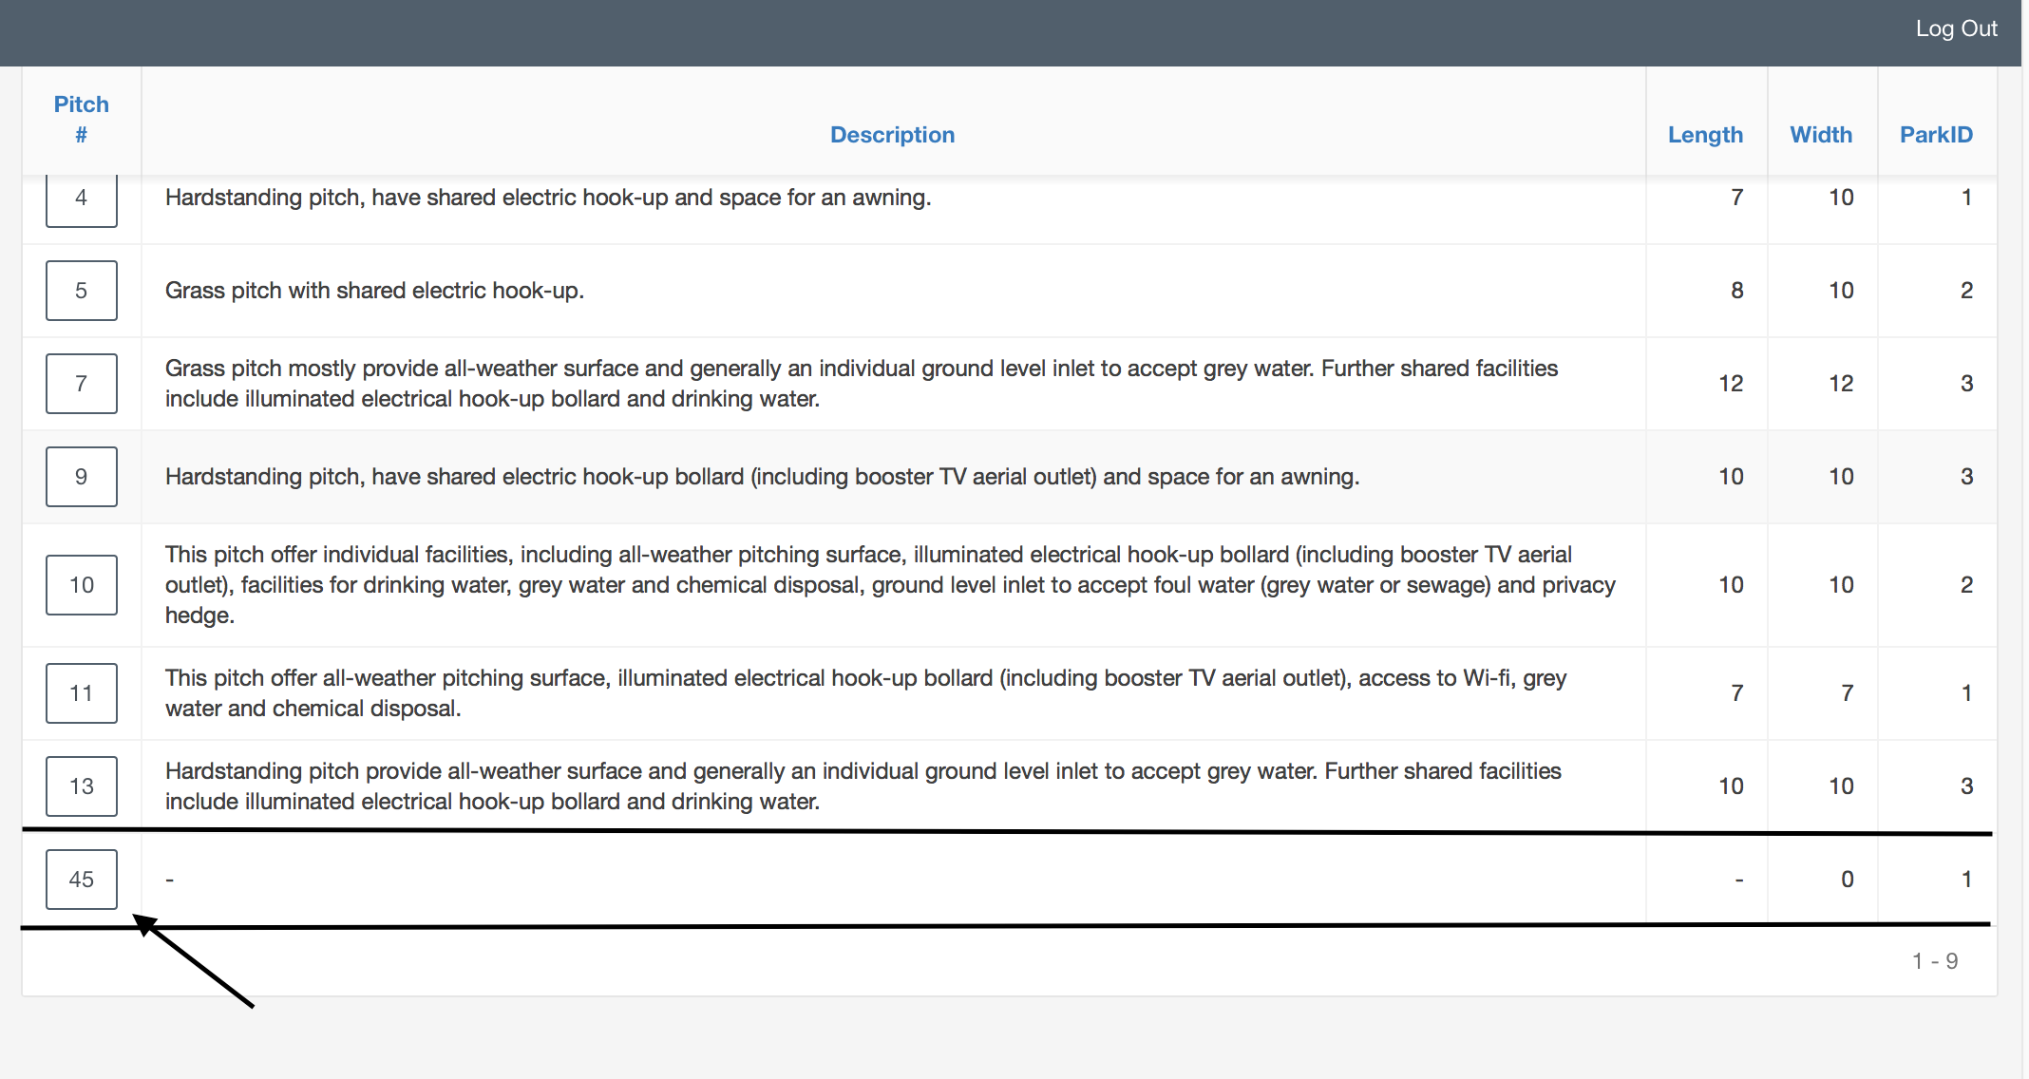

# UPDATE Pitch: a pitch record No45 has been changed:

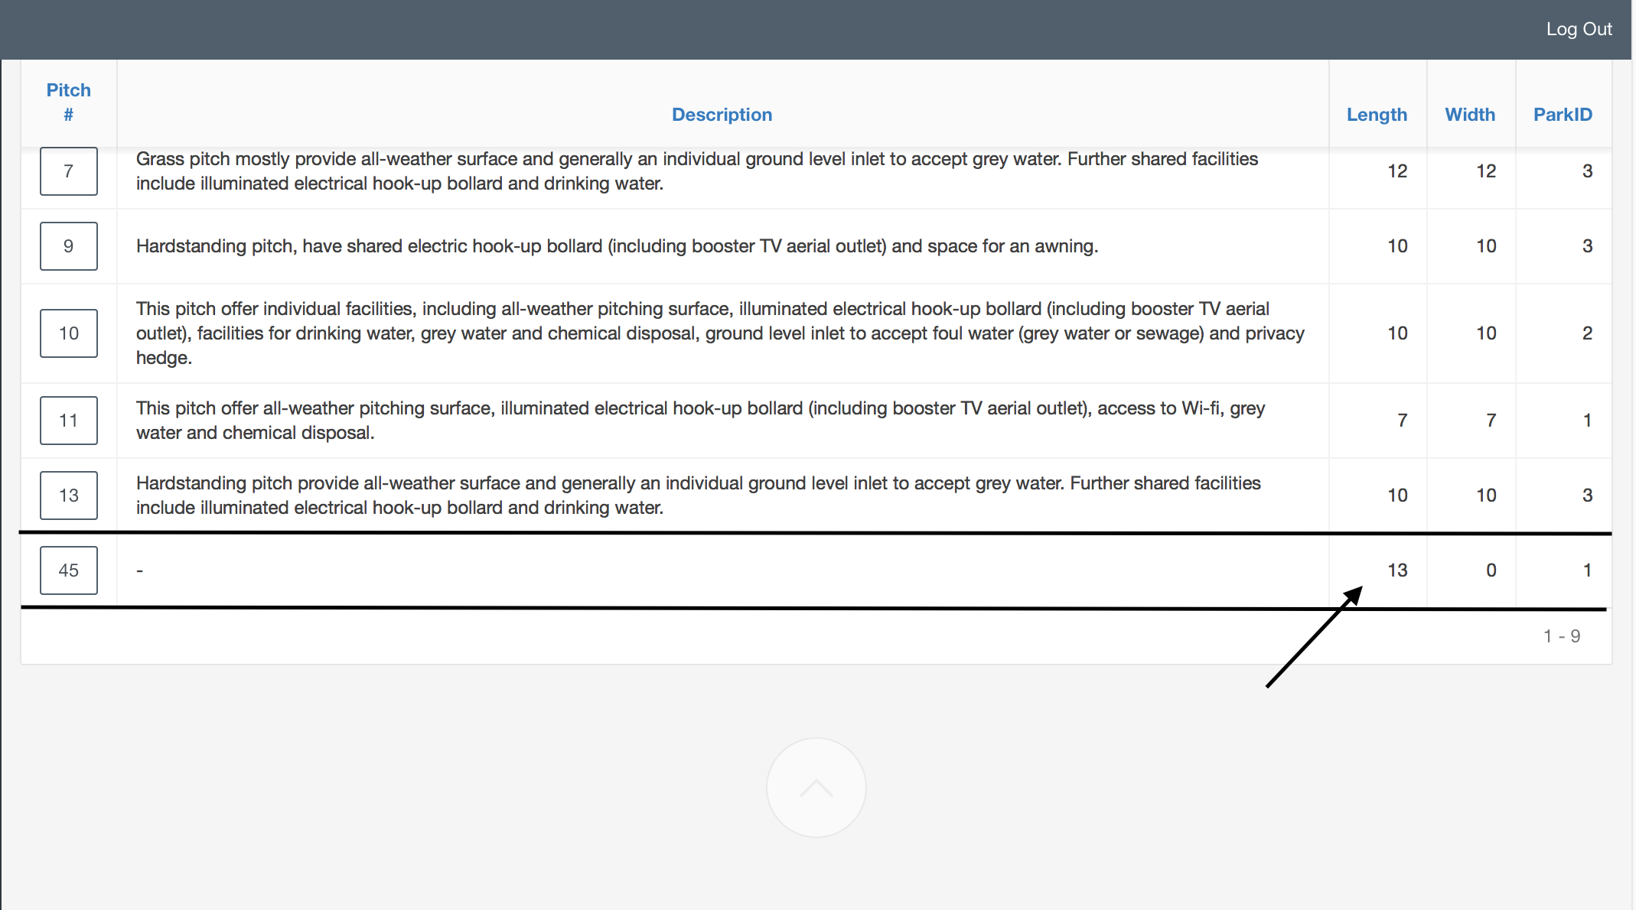

# DELETE Pitch: a pitch record NO45 has been deleted:

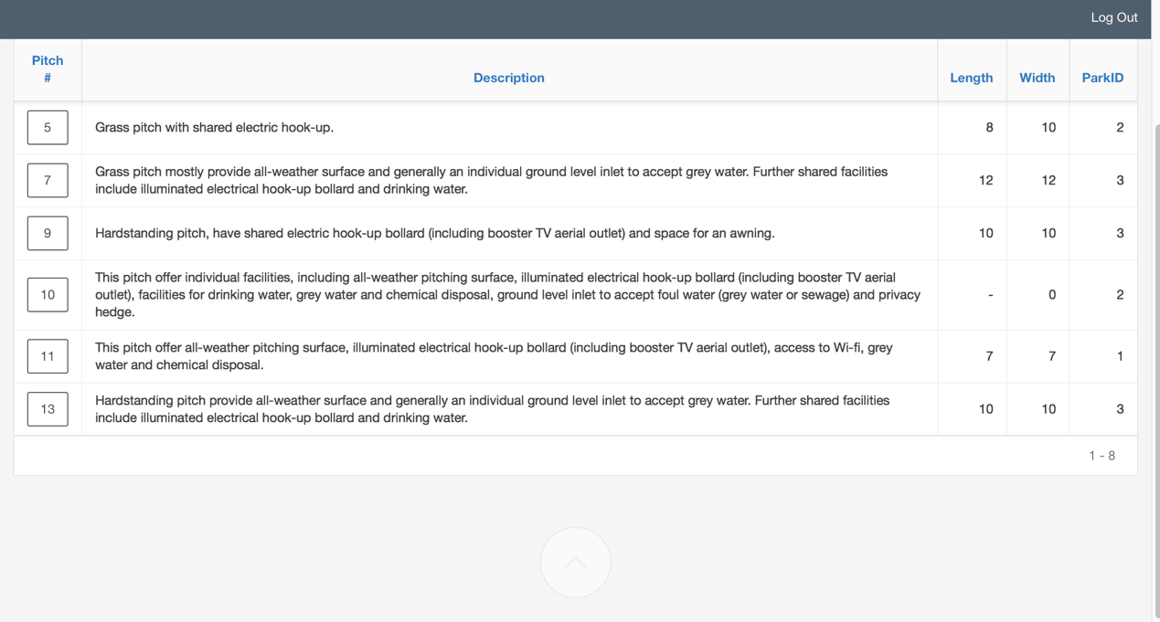

# Form 3: Page Owners . Master Detail

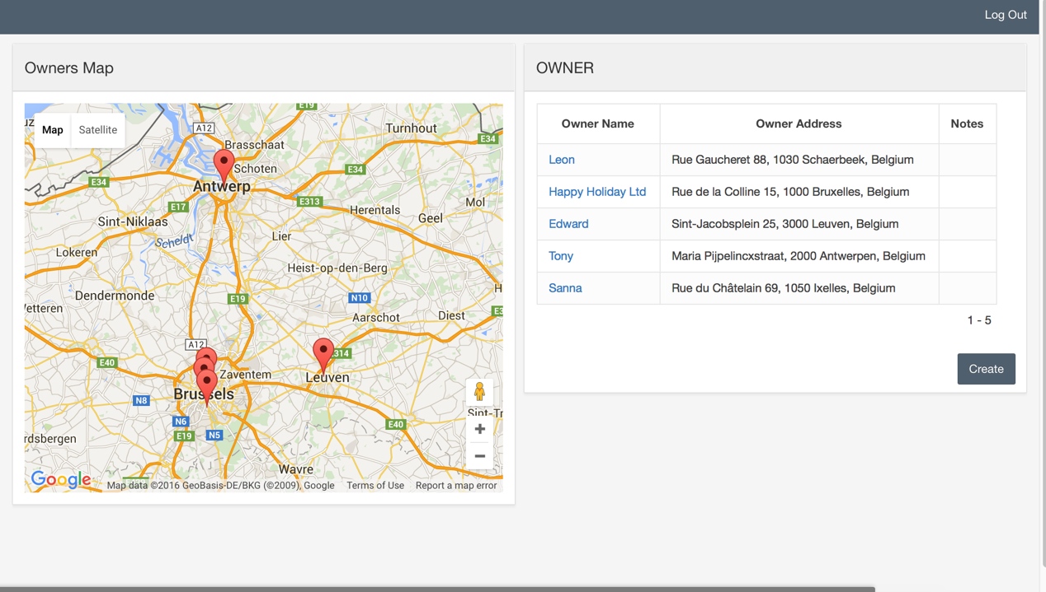

Owners Map – Plug-in & Map.

Owner Name – Link to the Master Detail Page.

**Plug-in&Map:**

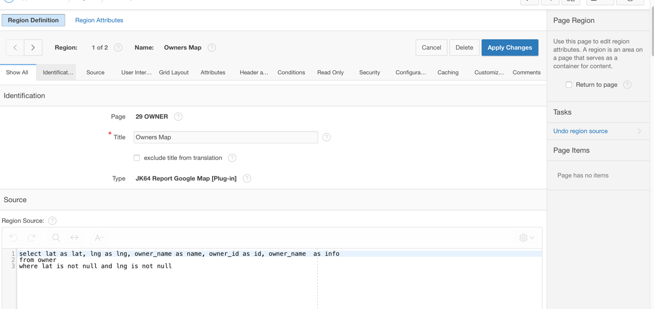

Selects only owners,who has lat and lng values .

I have chosen Belgue addresses ,because UK’s do not display correctly. Plug-in issue.

**Create Owner:**

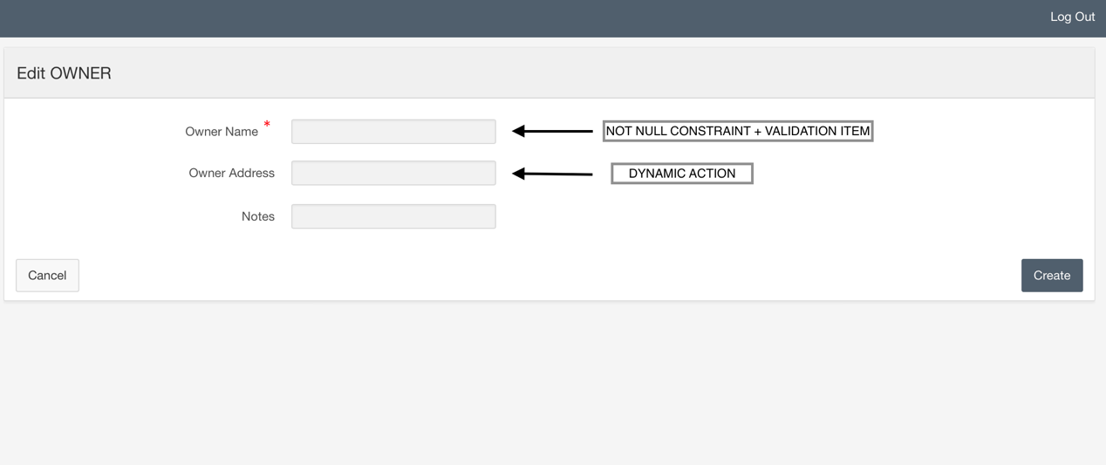

**Validation Item:**

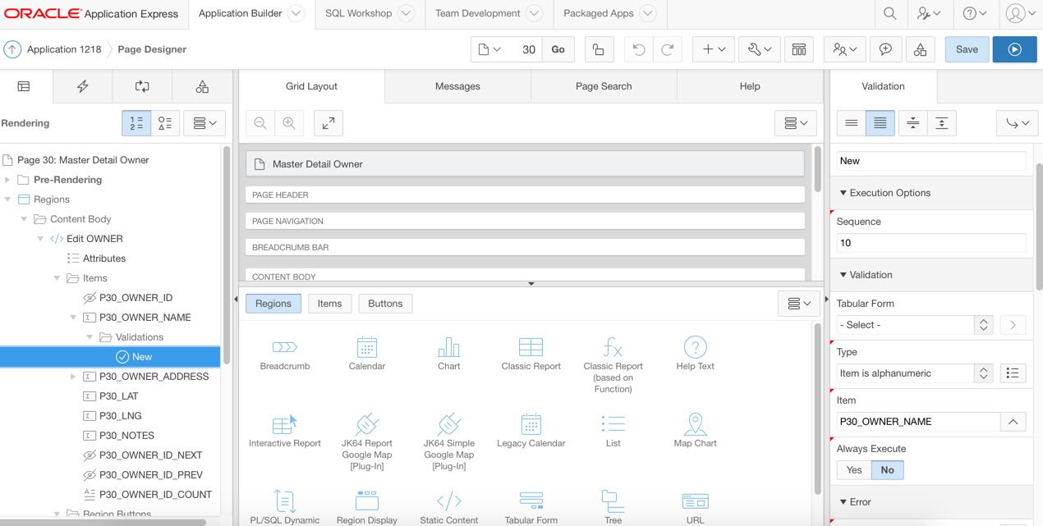

Must contain only alphanumeric values.

**Dynamic Action:**

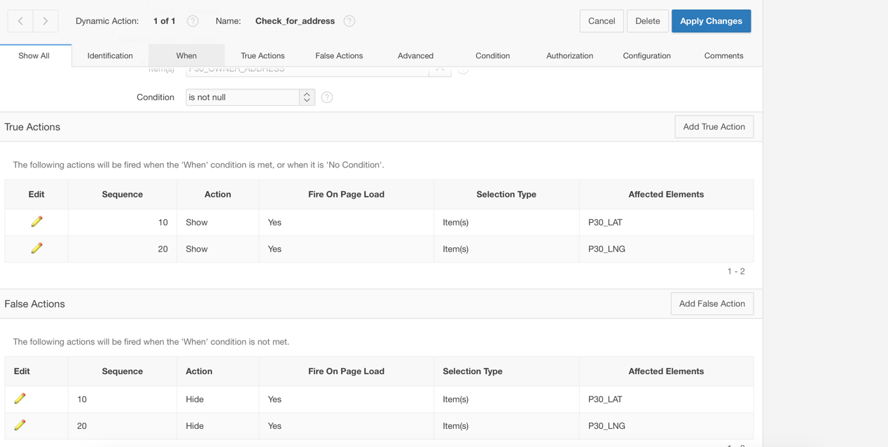

Id owner_adress in not null -> show lat and lng.

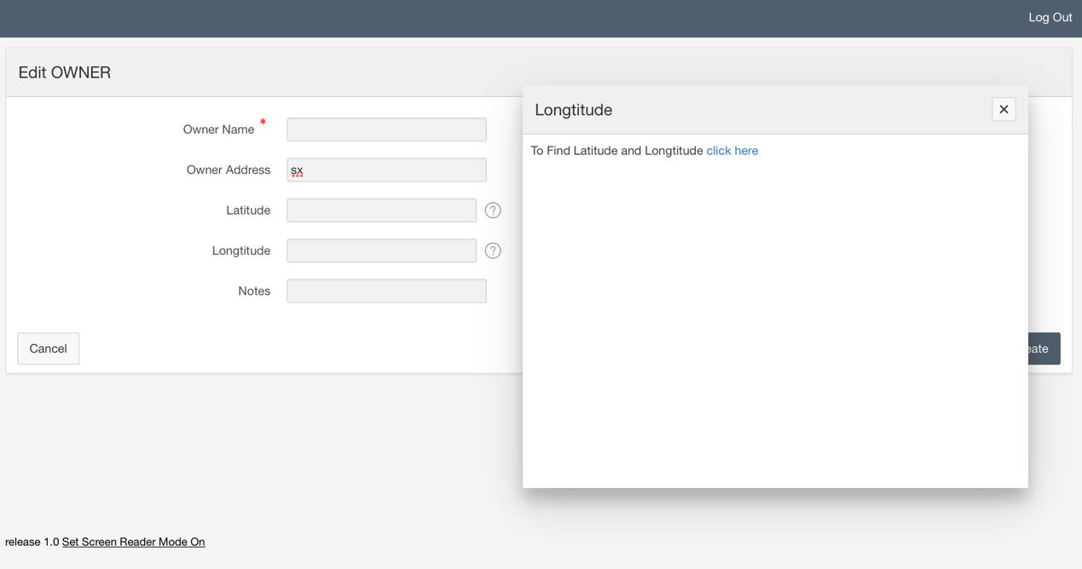

Help text for Lat and Lng field . “Click here” will redirect you to the external site, where you can just put address and it will find coordinates.

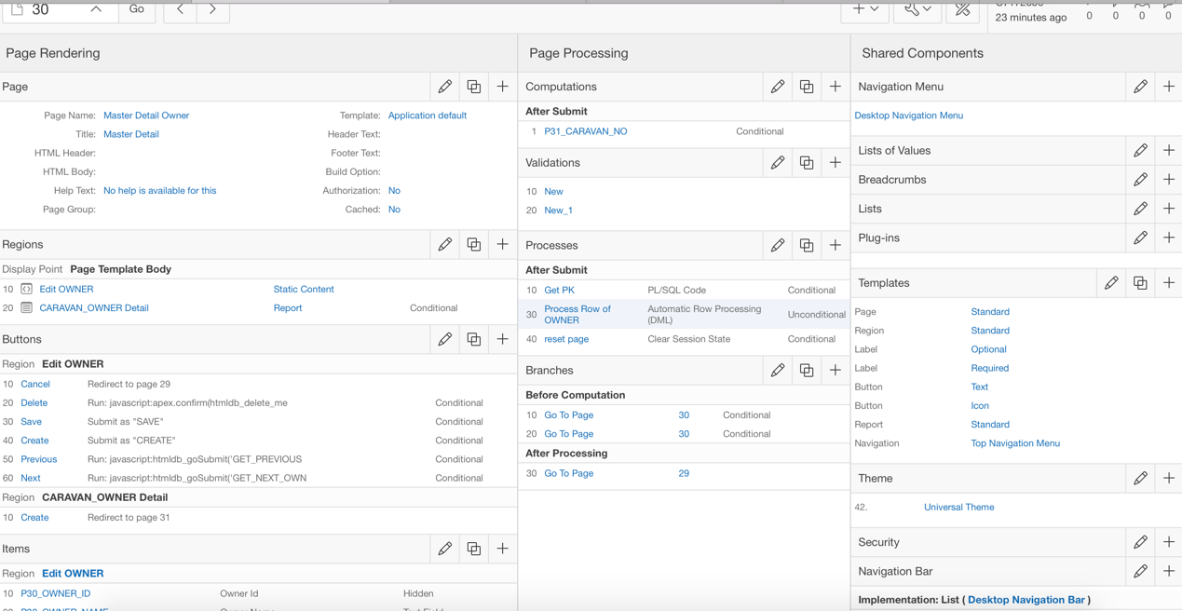

# INSERT Owner: A new owner record inserted:

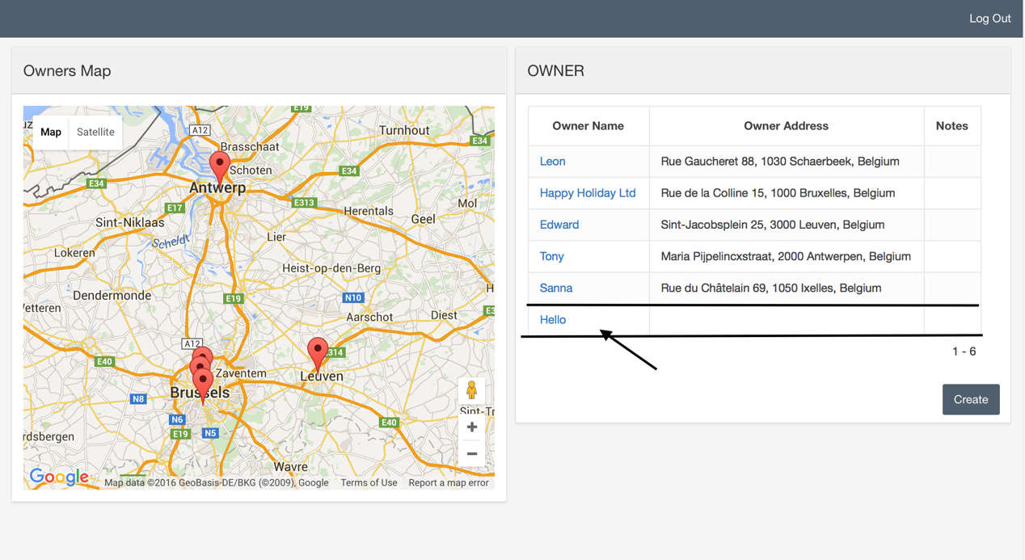

With no Address

# UPDATE Owner: an owner Hello has been changed:

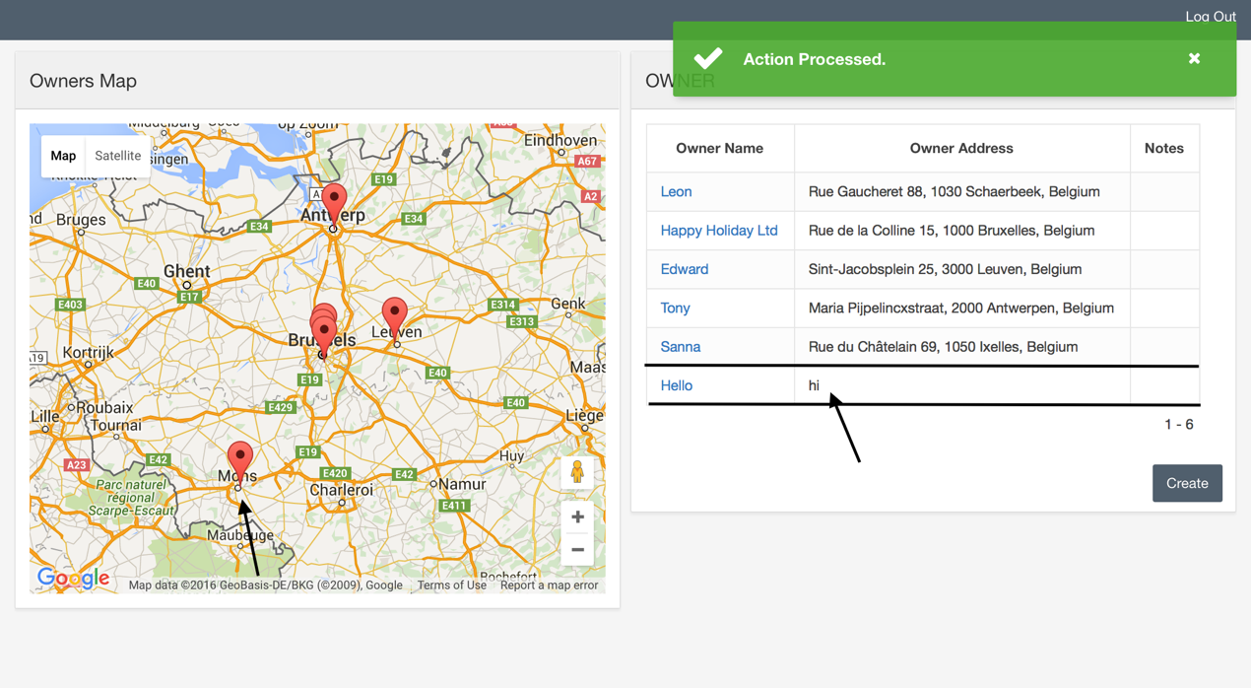

Added Address with lat and lng values.

# DELETE Owner: an owner Hello has been deleted:

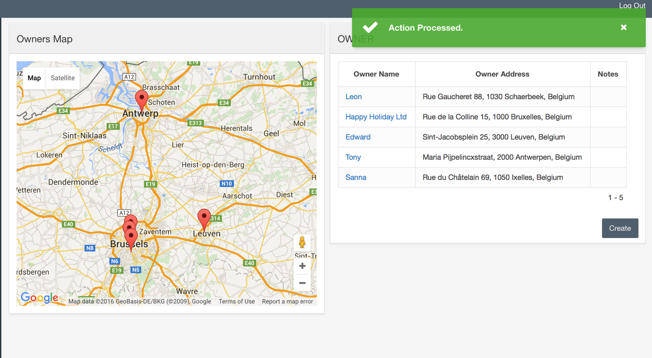

**MASTER DETAIL Page:**

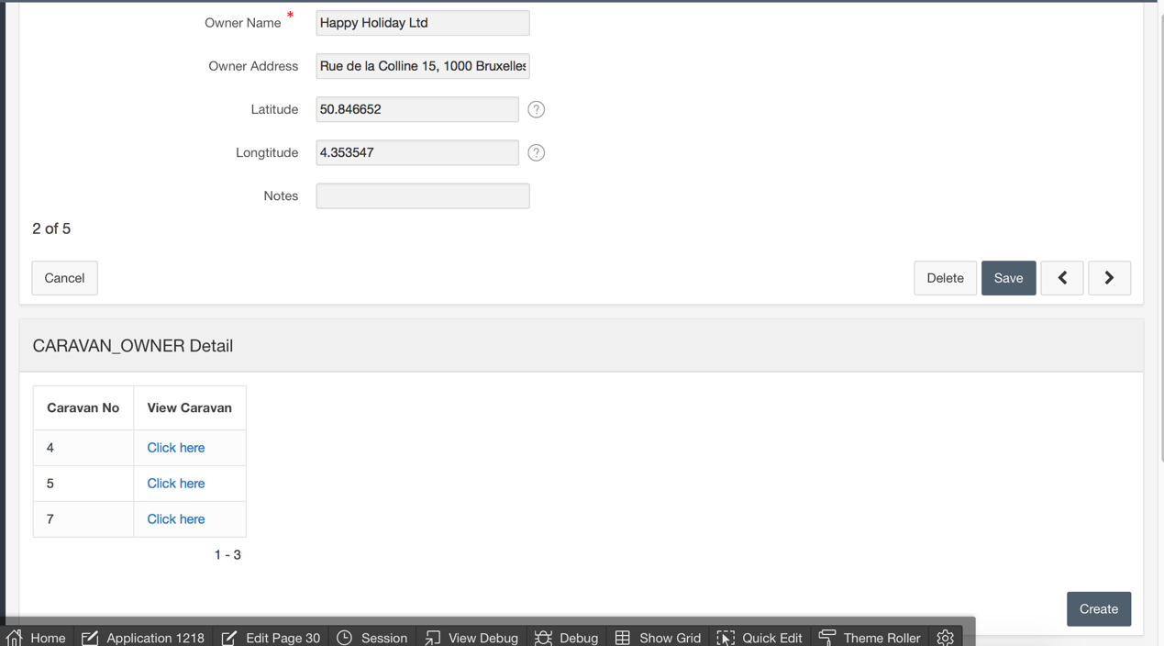

“Click here “ redirect you to edit page of the selected caravan.

**Example of “click here” link of caravanNo 5:**

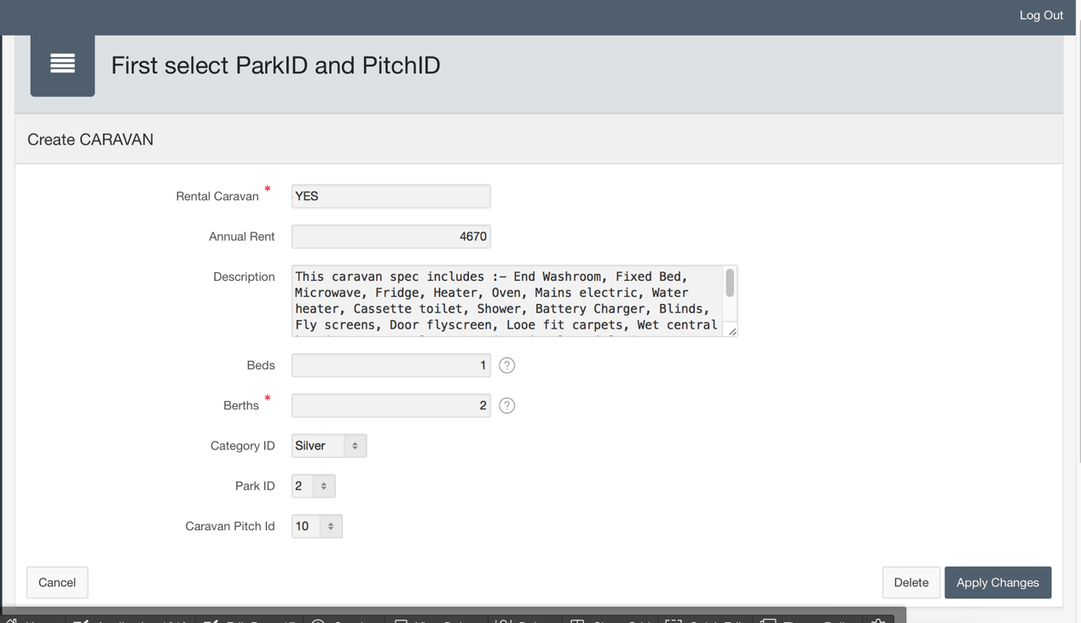

**CREATE Caravan for “Happy Holidays”:**

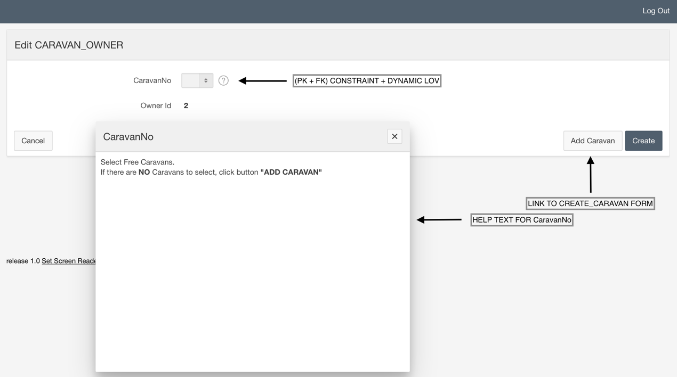

Here you can see Owner_ID for which you are adding caravan.   
For details have a look at Help Text of CaravanNo.

**Dynamic LOV:**

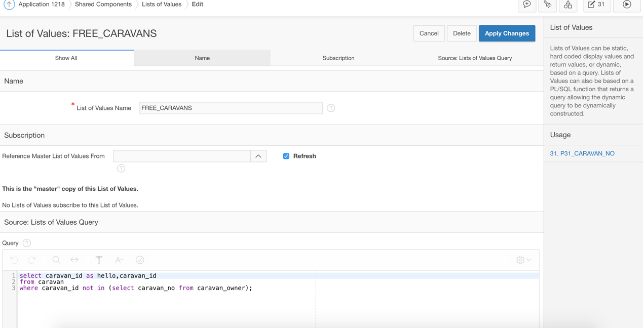

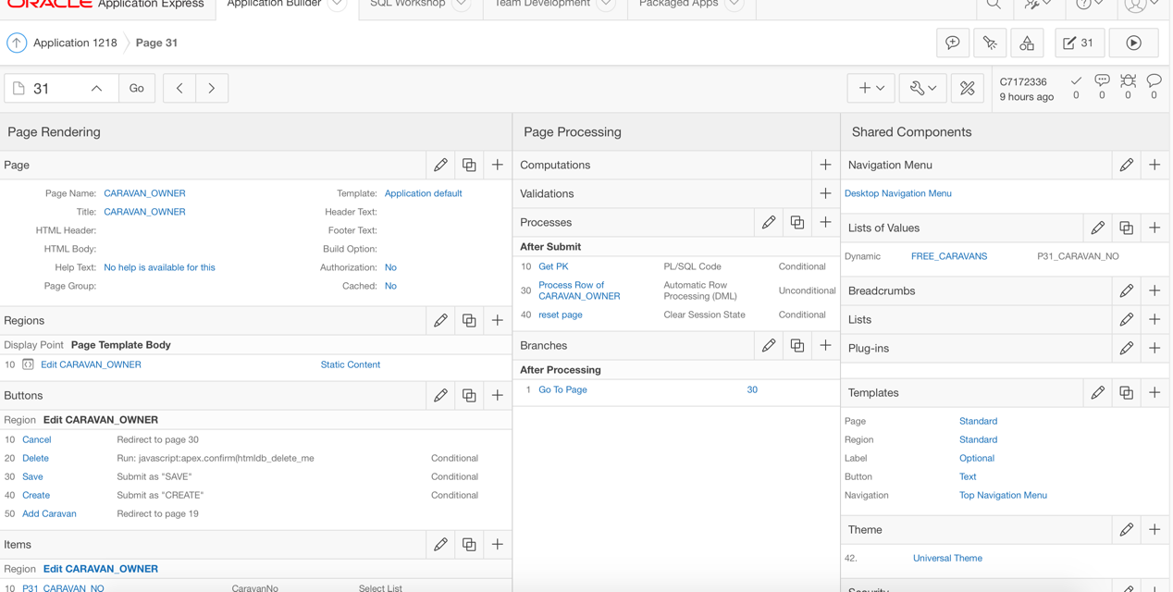

# INSERT Caravan_Owner: A new caravan_owner record inserted:

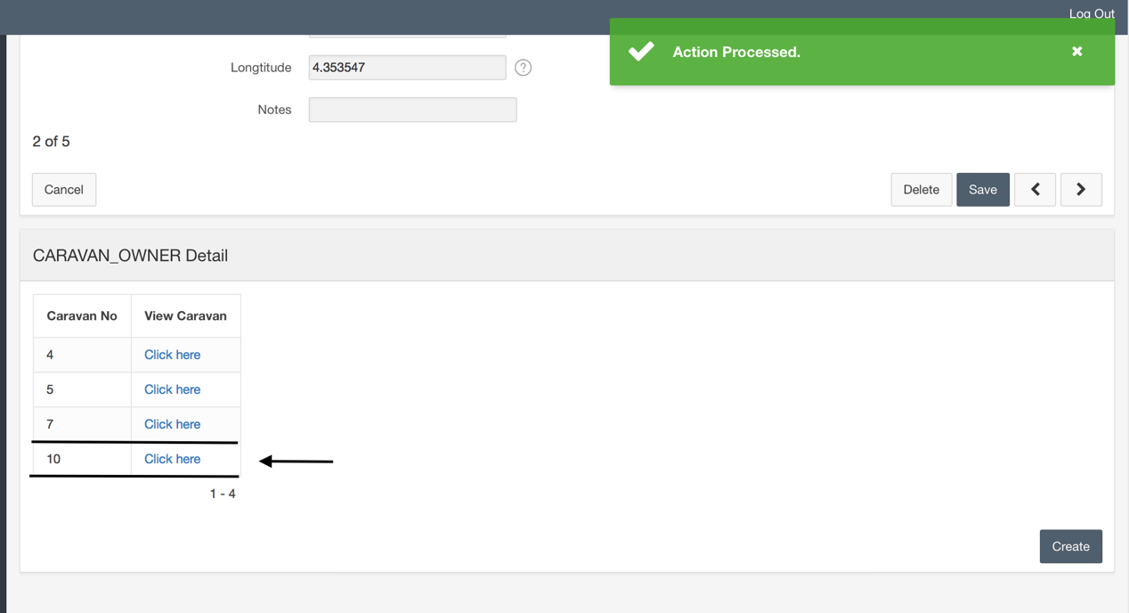

New caravan for Happy Holiday

# UPDATE Caravan_owner:

To update Caravan_Owner you have to:

1. “Click View” of the specific caravan.
2. In new page click “Delete”.
3. On page “Caravans” click “Create” and create a new one.
4. Then on page “Owners” select for which owner you want to add caravan -> click his name.
5. In Caravan_owner Detail Region click “Create” and select you caravan.

# DELETE Caravan_Owner: a caravan_owner NO10 has been deleted:

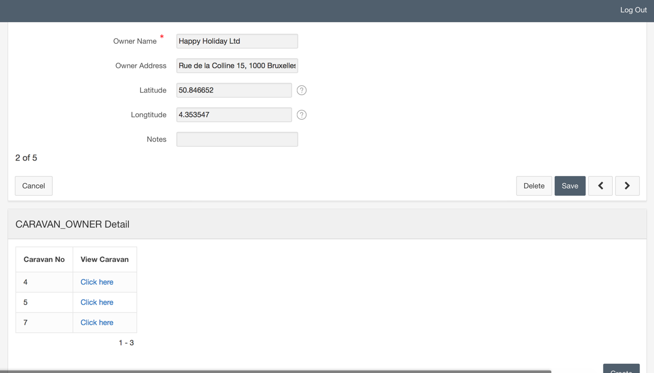

**Chart:**

